What is DB Primary?

DB Primary is our school’s ‘Primary Learning Cloud’. The Primary Learning Cloud is a safe area on the internet for pupils, and members of our school community, to share information and access a wide range of learning resources, anytime, anywhere.

DB Primary is specifically designed to improve digital literacy standards for primary school children and support the teaching of online safety. Included are online activities for Maths, English and Computing, along with Forums, Blogs, shared spaces and creative online tools.

Practical benefits for pupils:

DB Primary will enable pupils to:

- Access learning materials outside lesson time and from any location
- Store work and notes online for use in homework and revision
- Work at their own pace and with a wider choice of learning styles
- Improve their ICT skills and online management
- Participate in live discussions and forums with other students and teachers

Practical benefits for parents & carers:

DB Primary will enable parents and carers to:

- Support children with learning which takes place outside school
- Access their child's personal home page to keep track of their work and the curriculum
- Engage with wider school issues through online communication tools
- Become active partners with the school

If you do not have a computer with internet access, please let your child’s teacher know. Some activities added to DB Primary can be made available as a paper copy.

Please note that DB Primary does not filter the internet. You need to have your own internet firewall and parental controls set up.

How to log into DB Primary

You can find our school’s DB Primary login page on the school website, or via this address:

http://www.nettlesworth.durham.sch.uk

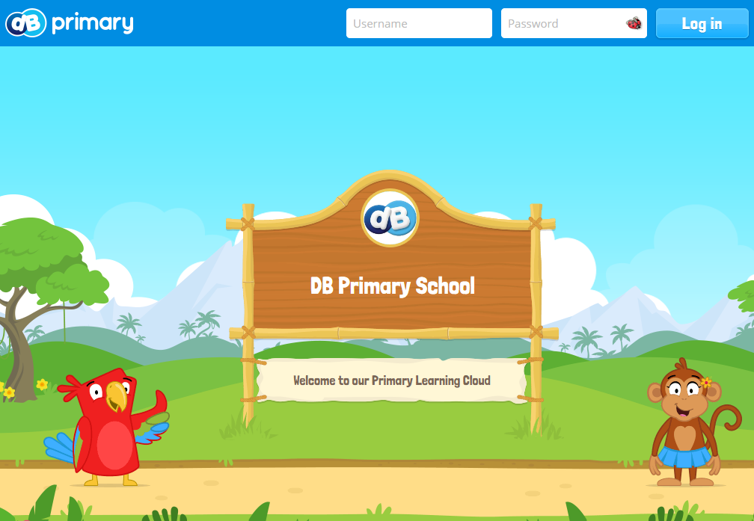

When on the login page, just enter your DB Primary username and password*. The school will provide you with these details.

You will now be logged into DB Primary - We hope you enjoy using it!

* If you forget your login details, please contact a member of school staff.

Guidelines for children

Please reinforce these Children's Guidelines with your child at home. Anything your child puts onto DB Primary can be seen by members of staff.

- Sensible behaviour when using the emails / blogs or forums.
- Make sure that any pictures you upload (profile picture, or pictures in posts) are suitable for a school audience.
- Keep your personal details, password safe.
- Write in full sentences.
- Sensibly express your opinions in forums.
- Email your friends outside school time.
- Share links to sites by posting them in your blog / forums.
Whistle alerts: Reporting inappropriate content
Inappropriate content can be reported to staff at the school by clicking on the whistle icon. A pop-up will appear to allow an explanation to be entered. The alert is sent to delegated DB Primary ‘whistle monitors’ at the schools.

The Whistle Monitor ensures that children are able to use DB Primary in a safe and secure way.

Internet safety websites

It is important for our pupils to use the Internet safely at school and at home. Please spend some time looking at these online safety websites:

Think you know
http://www.thinkuknow.co.uk/

KidSMART
http://www.kidsmart.org.uk/

BBC Stay Safe Articles and Links
http://www.bbc.co.uk/cbbc/curations/stay-safe

Nettlesworth Primary School
Primary Learning Cloud
An information leaflet for parents and carers

- What is DB Primary?
- Benefits for pupils, parents and carers
- How to log on
- Online Safety

