Headteacher : Mrs Donna Lee 7th February 2021

E-mail: d.lee103@durhamlearning.net

Website: http// www.nettlesworth.durham.sch.uk
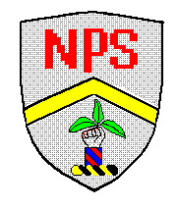
Spring Term Newsletter

Public Health Updates
Public Health updates
Public Health have created a webpage with information for parents about the rules that they must follow to help prevent the spread of Covid-19. There is also information for parents about what to do if their child is asked to isolate because they have had contact with someone with Covid-19 (both a web link and a printable/emailable pdf).
https://www.durham.gov.uk/article/24952/How-to-prevent-the-spread-of-Covid-19-if-your-child-is-at-school
https://www.durham.gov.uk/article/24953/Self-isolating-for-schools

Mental Health Matters
Children’s Mental Health Week (New)
For the toolkit that has all of the resources that you will find on our news page and class pages last week check out the link below:
childrens-mental-health-week-toolkit-final

Lateral Flow Tests For Primary Staff
As you may be aware the government, in conjunction with the NHS, are instigating a programme of Lateral Flow Testing for primary school staff which we started on Monday 25th January 2021.

The aim of the testing is to identify asymptomatic carriers of the virus in order to break the chains of transmission. While the testing is for staff only – not children – and therefore any organisation and implications for the actual testing is for us alone, the implications of identifying positive cases impacts on all.

We have been very fortunate as a school to not have had any positive cases leading to bubble closures so far but this does not mean we have not, nor will not, have staff who are asymptomatic carrying the virus.

School staff are now undertaking the Lateral Flow tests twice a week.

These tests are undertaken at home. If a test identifies that a member of staff is positive, then they will need to self-isolate immediately and inform me of the result (headteacher). The school will then follow the test and trace protocol we have had in place since September, which follows NHS, DFE and LA guidelines.

If a bubble needs to be closed, the closure will come into effect immediately. Parents will be informed by email/text. The member of staff will then book a PCR test for conformation. In the unlikely event that the PCR test returns a negative result the bubble will be reopened and parents informed of this with timing details
DB Primary Platform for Remote Learning
DB Primary Tips:

Welcome to DB Primary Power Point – PARENTS
DB Primary Parent Guide-58095
Developing-Online-Safety-in-the-Primary-School-through-DB-Primary-A-guide-for-parents-and-carers
We are very impressed with what has been completed and the engagement from our children. There have been a few issues raised from parents and children so here are some tips which might assist you from next week:
- Accessing DB Primary through an iPad – this is better if done through Google Chrome rather than Safari – Google Chrome can be downloaded free from the App Store
- You can access DB Primary by clicking on the link on our school website home page or remote learning page under parents heading
- If a word document doesn’t look right when you click on it, try downloading it first and then opening it.
- If you can’t print out worksheets or if you need to you can write on any piece of paper, take a photograph and upload it to DB Primary. If anyone needs an exercise book to work from, please email us and you can collect one from school
- We believe that DB Primary can be accessed through X-Box and Playstations. It will give your child access to a lot of content.

o X-Box
- Plug a key board into the X Box USB slot – or use the games controller
- Go in to my games and apps
- Type in: https://nettlesworth.durham.dbprimary.com

o Playstation
- Identify the Play Station internet browser icon (it is WWW with dots around it)
- Press the PS4 logo on the controller
- Go to the library and find options for games and applications
- Go in to applications and you will find the internet browser
- Type: https://nettlesworth.durham.dbprimary.com
If anyone is struggling with accessing remote learning or is having data issues, please contact us!

Some of the wonderful home learning in Class 1
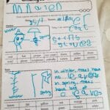
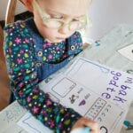

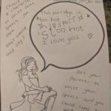

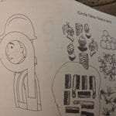
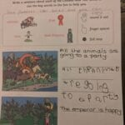

Class 2 Home Learning

The best education is always done outdoors Alana
Excellent work Alana
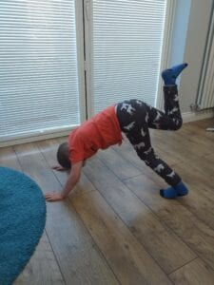Excellent gymnastics Harry

Class 3 Home Learning
Robyn has been been thinking about her future career goals, she has decided she’d like to be a fashion designer! You will be amazing at that Robyn.
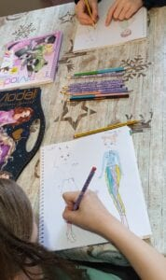
Jenson got active with his brother to do yoga for PE. Well done Jenson!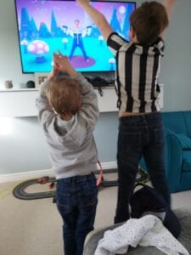

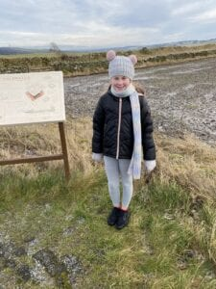

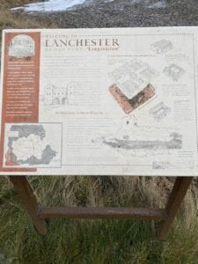
Amelia learned more about our topic at the weekend, here she is at an old Roman military fort route at Lanchester, that leads to Hadrian’s wall. Well done Amelia.
I love Emilia’s dog drum she made for her science sound investigation. Excellent job Emilia.
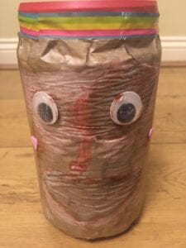
Here are a few examples from Class 4
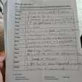
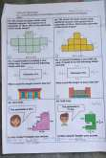
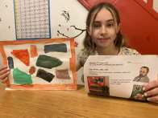
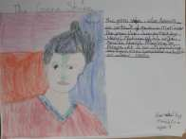
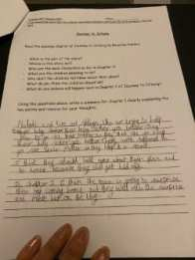
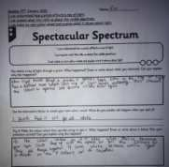
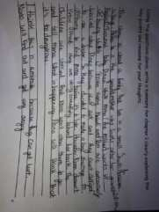

Texts/Mail
We regularly send texts/mail to parents with details of events happening in school or just reminders. Please notify school if you haven’t received any texts/mail in the last month. Your contact details may need updating.
School Website
Please continue to look at our school website on www.nettlesworth.durham.sch.uk for diary dates, latest news, celebrations, advice and information.
Loan of Devices to Support Home Learning
Loan of Devices (Laptops) to Support Remote Learning
As you may be aware the government has a scheme to provide laptops to children who do not have devices/internet access at home.
At the time of writing, Government guidance states that children who are eligible for this are those in Years 3-6 where any of the following are applicable:
- There are no digital devices in your household
- The only available device is a smartphone
- There is only one device in your household which is being shared with more than one other family member
- Your child is clinically extremely vulnerable and having to shield
If your child falls into any of the above categories, the school has been allocated a limited number of devices to loan to children in order for them to continue with their learning remotely from home. These should be available shortly.
The scheme is a loan system. A laptop would be loaned to any eligible pupil for the duration of school closure. There will be a loan agreement to be signed and the laptop will have to be returned once school is re-opened.
If you believe that your child is eligible for a home device, please contact school office on 01913710444 or email d.lee103@durhamlearning.net
Absences
If your child is unwell, please contact school office as soon as possible by 9am. It is important that children attend school as often as possible because if they are not in school they cannot learn
Home Learning-Online Safety
DCC Online Safety advice for parents and carers during Covid 19
Parents and carers will want to make sure that their children are as safe as possible.
Parental Controls
Almost all devices allow parental controls to be set. These can be adjusted
depending on the ages of the children. They can:-
• Stop children putting new apps on a device until the parents approve them
• Reduce the chance of a child accidentally spending money on virtual goods
• Limit the time that children use a device without having a break

A good starting point is the internet matters website
https://www.internetmatters.org/ , go to the SETTING CONTROLS section at
the top!
Talking
Probably the best thing you can do to help your son or daughter is to talk to them
regularly about how they use technology, which apps and sites they use and who
their online friends are. Some children struggle with online relationships perhaps
either sending or receiving hurtful messages. Parents and carers will be able to help
guide youngsters through this difficult area. If children receive unpleasant messages
these can usually be reported and each app or site will have a different way of doing
this.
Apps and Sites
The list of apps and websites children are using grows by the minute so printed
advice is likely to be out of date. In the UK the NSPCC have a site called Net-Aware
https://www.net-aware.org.uk/ which explains many current apps, the risks and the
benefits of their use. More apps are listed on the American site Common Sense
Media https://www.commonsensemedia.org/
Activities for Children
https://www.thinkuknow.co.uk/ is the website aimed at children and their parents
from the National Crime Agency. It has lots of useful suggestions and advice on how
to report issues. It also has games and activities including Jessie and Friends for the
younger children and Band Runner for the older ones.
For the youngest children being tricked into sharing pictures can be an issue. LGfL
have produced a lovely free video https://undressed.lgfl.net/ which has some great
advice and a very catchy song!
More Help?
Children can call Childline on 0800 1111 for advice on anything that is worrying
them.
Finally since 2015 is has been a criminal offence for an adult to send a message with
sexual content to a child (This is Section 67 of the Serious Crime Act 2015). If
you are concerned that this might have happened please contact The Police without
further using the device. This will help ensure that evidence can be preserved. The
Police can be contacted by phone or from the Thinkuknow website.
https://www.thinkuknow.co.uk/

Citizens Advice Energy Programme
Citizens Advice have issued some guidance about a new project. Across England, over 2.4 million households are classed as being fuel poor. The aim of this project is to assist new & existing clients with expert energy advice to maximise their income and reduce fuel poverty. The Citizens Advice Energy Advice Programme is now live and can help clients save money and manage their energy use more effectively through providing help and advice with the following:
❖ Fuel vouchers
❖ Energy tariffs
❖ Switching energy supplier
❖ Energy efficiency
❖ Fuel debts
❖ Meters
❖ Smart meters
❖ Grant applications
❖ Additional help and support from suppliers

If you would like our support with any of the above or you find yourself struggling to meet your energy costs, please give them a call on: 07592649158. Alternatively, you can contact them by going to citizensadvice.org.uk or calling our Advice line on 03444 111444.

Various Support Services and Information during these Challenging Times
Please find information about supporting families who have children with emotional and mental health.
Rollercoaster Services – parent and carer support

Supporting Primary Aged Children to return to school
The Mental Health Support Teams have produced a guidance document for parents with information around supporting their primary aged children to return to school. I have attached it for your information as you may find it useful.
Preparing your child to return to school NEW (1)

Looking after our Mental Wellbeing
There are things we can all do to help look after our mental wellbeing during this challenging time. Whether it’s staying connected with friends and family via phone and video calls, creating a regular routine or looking after our body through physical exercise, we all need that extra support to help deal with stress, boost our mood and feel on top of things
Visit everymindmatters.co.uk to get your Mind plan today. #everymindmatters #coronavirus

Tackle Child Abuse Together
Would you recognise the different signs of child abuse?
If you think it, report it. You can call your local council or the NSPCC or the police.
Visit tacklechildabuse.campaign.gov.uk/ so we can #tackleabusetogether

Look after your mental health
A range of content designed to give you more information about mental health and to help you to look after your mental health is available from the Mental Health Foundation
https://www.mentalhealth.org.uk/your-mental-health

Keeping Children Safe Online
Keeping our children safe online is a priority for us all.
Please access these links to see what things you can do at home to ensure that your children are safe online.
https://www.thinkuknow.co.uk/parents/
https://www.thinkuknow.co.uk/…/our-views/parents-helpsheets/

Harbour
Harbour works with families and individuals who are affected by abuse from a partner, former partner or other family member.
If you or someone you know is being abused or being abusive to others the please use the information below:
- If in immediate danger always call 999
- Harbour 24-hour support line 03000202525
- Email info@myharbour.org.uk
- Information available on myharbour.org.uk
- Harbour facebook page
National Helplines:
- National Domestic Violence Helpline 08082000247
- Men’s Advice line, for male domestic abuse survivors 08088010327
- The Mix, free advice for under 25’s in UK 08088084994
- National LGBT+ Domestic Abuse Helpline 08009995428

Sacriston Youth Project
Weekly Sessions
After School Club
4-5pm
Tuesday
Lunch Club
12-1pm
Wednesday
Two weekly opportunities for the children to get together to join in fun stuff, from creative activities to weird science, quizzes, challenges and much more, with the overall aim to promote kindness, friendship, social cohesion and support our children in being part of an active community. Although parents and carers are expected to supervise at arms length, it is also intended to give parents a little me-time whilst the children are engaged in some meaningful activities.
Monthly Sessions
Gourmet Kids Saturday Kitchen
First Saturday of the Month
Saturday 6th February
11am
Each month you can collect a box and we will host a live Zoom from our Gemma’s kitchen, where her and Beth will cook up a storm using fresh ingredients! We will look at cooking on a budget, nutrition and having fun in the kitchen. We’ll have some guests too! ￼You MUST commit to joining the Zoom and picking up on time to be part of the project.
Family Focus Social
Second Wednesday of the Month
Wednesday 10th February
6-7pm
A social group to give parents and carers the opportunity to meet like minded people and maintain a sense of community. The sessions focus on the adults in the home rather than the children. There will be a focus on health and wellbeing, and hints on tips to support your parenting in a practical and do-able way.
Meet the Expert Family Focus
Last Wednesday of the Month
Wednesday 25th February
6-7pm
Zoom monthly with an expert… someone who can provide awesome and inspiring advice to help you gain confidence in your lifestyle and overall well-being. There will be a presentation followed by a Q&A session.
There is also support on social media via…
(8) SYP Family Forum | Facebook
(8) SYP Gourmet Kids | Facebook
(8) Sacriston Youth Project | Facebook
All booking enquiries for sessions should be directed to gemma@sacristonyouthproject.co.uk
February Half Term
All schools will close as usual over the half-term and are not expected to stay open for vulnerable pupils and children of critical workers. We end for half term Friday 12th February 2021 and re-open for Key worker/Vulnerable Children and Remote Learning Monday 22nd February 2021
The Local Authority will use funds from the Covid Winter Grant Scheme to provide families with meal support over this time. These vouchers will be emailed to our Families.

I would like to thank everyone in our school community for everything they are doing at this time to ensure we all stay as safe as possible. My thoughts go out to families who have to self-isolate, have loved ones ill at this time or families who have lost loved ones. I know that the strength we had as a community during the first lockdown helped us through and I am sure this will be case again. We are here to support you in every way, so please get in touch with us, sometimes just a chat can help
Thank you again for your continued support
Mrs Donna Lee
Head Teacher

