Name:_______________________ Monday 14th March 2022
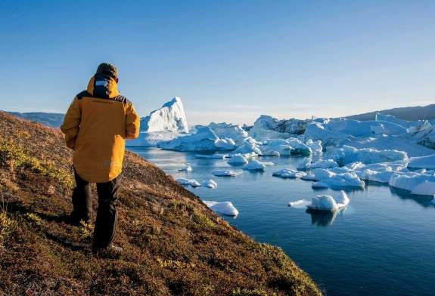
Class 5 Homework – Frozen Kingdom / Geography

Polar Travel
For your homework this week, your challenge is to read a range of specialist polar travel brochures and websites, making a list of activities available and special things to see on a polar trip – try to link your homework with the work you are currently doing in class. Once you have enough activities, you job is to write an imaginary postcard as if you are on a polar holiday, telling someone at home about your exciting, icy activities.
Try to be as creative and imaginable as possible in your writing. Can you draw a diagram of one of the activities you have done?
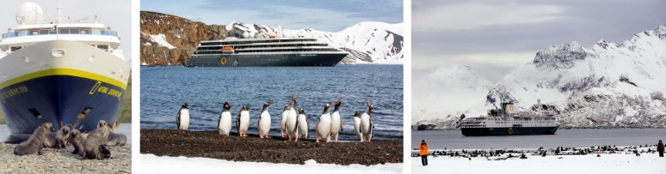
Here are some websites you could explore…
https://www.quarkexpeditions.com/en
https://www.discover-the-world.co.uk/
http://www.intrepidtravel.com/uk/
https://www.theaurorazone.com/
http://www.polarcruises.com/

