Name:_______________________ Monday 28th March 2022
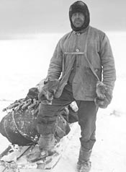
Class 5 Homework – Frozen Kingdom

Robert Falcon Scott
Robert Falcon Scott, known as Scott of the Antarctic, is a very famous Polar Explorer.
- Do you know what makes this man famous?
- Why is he important?
- Why did he wear his particular clothing?
- When do you believe he might have lived?
Your homework this week is to create a portfolio for Robert Falcon Scott and try to include as many interesting facts about his fascinating work and discoveries.

