Monday 13th June 2022 – Class 5 Homework – Bamburgh Name:________________

Q1.
x + 2y = 20
x and y are whole numbers less than 10
What could x and y be?

x =
y =
1 mark
Q2.
Amina is making designs with two different shapes.
She gives each shape a value.
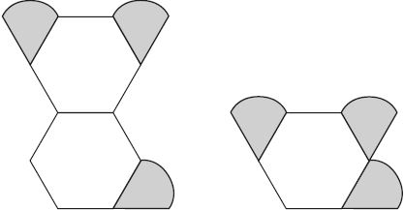
Total value is 147 Total value is 111
Calculate the value of each shape.
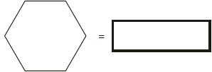
1 mark
1 mark
Q3.
A shop prints designs on T-shirts.
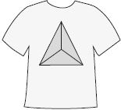
They use this formula to work out the price for printing a design.

price = 60p × number of colours + £1.25
What is the price for printing a design that has 3 colours in it?
1 mark
Amina has £5 to spend on printing a design.
What is the greatest number of colours she can have in the design?

2 marks

Q4.

In this diagram, the shaded rectangles are all of equal width (w).
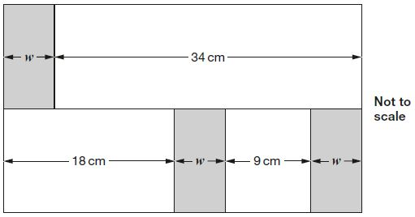
Calculate the width (w) of one shaded rectangle.

2 marks

Q5.

Here is a pattern of number pairs.

a | b
1 | 9
2 | 19
3 | 29
4 | 39
Complete the rule for the number pattern.
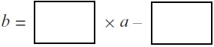
1 mark
Q6.

n = 22
What is 2n + 9?
1 mark
2q + 4 = 100
Work out the value of q.
1 mark
Q7.

Here is an equation.
k = 100 − 4n
(a) Find the value of k when n = 60
1 mark
(b) Find the value of n when k = 99
1 mark
Q8.

n stands for a whole number.
2n is greater than 30
5n is less than 100
Write all the numbers that n stands for.

