Monday 13th June 2022 – Class 5 Homework – Lindisfarne Name:________________
Q1.
A theme park sells tickets online.
Each ticket costs £24
There is a £3 charge for buying tickets.
Which of these shows how to calculate the total cost, in pounds?

Tick one.
number of tickets × 3 + 24
number of tickets × 24 + 3
number of tickets + 3 × 24
number of tickets + 24 × 3
1 mark
Q2.
Dev says,
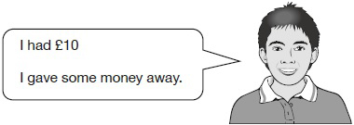
Which expression shows how much money Dev has left?
a is the amount of money, in pounds, that Dev gave away.

Tick one.
10 + a
10 ÷ a
a – 10
10 – a
a × 10
1 mark
Q3.

Here is a rule for the time it takes to cook a chicken.

Cooking time = 20 minutes plus an extra
40 minutes for each kilogram
How many minutes will it take to cook a 3 kg chicken?
1 mark
What is the mass of a chicken that takes 100 minutes to cook?
1 mark

Q4.

Each shape stands for a number.
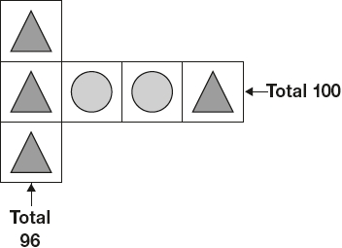
Work out the value of each shape.
1 mark
1 mark
Q5.

What is the value of 4x + 7 when x = 5?

1 mark
Q6.

n stands for a number.
n + 7 = 13
What is the value of n + 10?

Q7.
Each shape stands for a number.
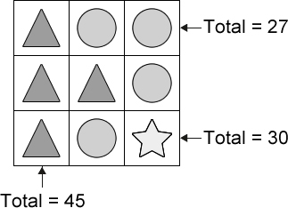
Work out the value of each shape.
1 mark

