Class 5 Homework – Bamburgh – 20.6.22 Name:____________________
Q1
Plants on the school field
(a) Some children are finding out about plants. They get three buttercup plants. They put each plant in a place with different conditions.
After two weeks, the buttercup plants look like this:
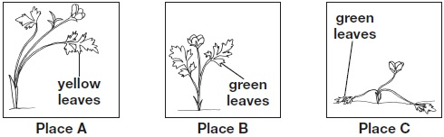
Write A, B, and C in the table below to match each place to the conditions found there.
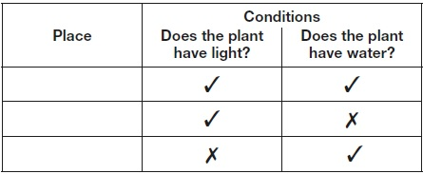
1 mark
(b) There are differences between plants.
These differences help people sort plants into groups.
Write true or false next to each reason that explains why plants need to be sorted into groups.

 | Plants need to be sorted into groups... | True or False?
 | to stop plants becoming extinct. | ____________
 | to help people identify plants | ____________
 | to help plants reproduce. | ____________
1 mark
(c) The children look at different plants on the school field.
They record the number of common plantain and buttercup plants in 1m² in different places. | 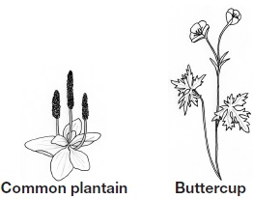
The children think they see a pattern in the place that the plants grow.
The table shows their results.
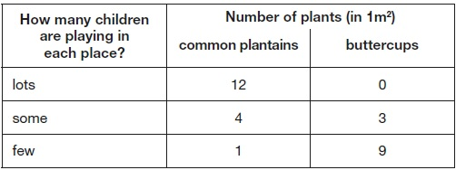
Describe the relationship between how many children are playing in a place and the number of common plantains found there.
___________________________________________________________________
___________________________________________________________________
1 mark
(d) The buttercup plant has a long thin stem.
The long thin stem of the buttercup plant stops it surviving in places where lots of children play. Explain why.
___________________________________________________________________
___________________________________________________________________
1 mark

