Class 5 Homework – Lumley – 20.6.22 Name:____________________
Q1.
Sea creature
(a) The picture shows the fossil of a pliosaur.
These animals lived in the sea a long time ago.
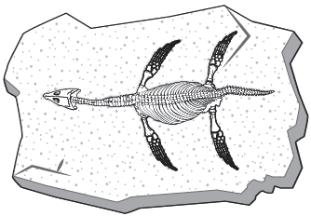
What material are fossils made of?
........................................................................................................................
1 mark
(b) How did the fossil of the pliosaur form? Match each stage to order what happens.
Stage What happens

1st |  | Soft parts decayed away.
2nd |  | Hard parts were turned into fossils over many years.
3rd |  | Hard parts were buried by many layers of sand.
4th |  | The pliosaur died and sank to the sea bed.
1 mark
(c) Very few animals become fossils after they die.
Explain why very few animals become fossils after they die.
1. ...................................................................................................................
2. ....................................................................................................................
1 mark
(d) Fossils can give a lot of information about animals that lived in the past.
Write true or false for each statement about the pliosaur fossil.
The pliosaur’s fossil could give
us information about...
True or false?
how long ago the animal lived. ......................................
what the animal ate. ......................................
what the animal smelt like. ......................................
what colour the animal’s eyes were. ......................................
how large the animal was. ......................................
2 marks

