Class 5 Homework – Lindisfarne – 20.6.22 Name:____________________

Q1.
Tree
(a) Ella is looking at some leaves.
The key below identifies which tree each leaf comes from. | 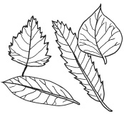
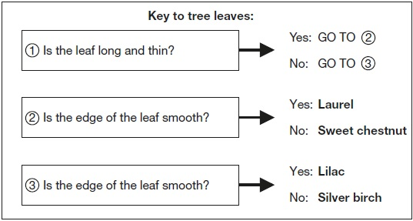

Look at this picture of a leaf from one of the trees. | 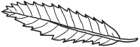
(i) Use the key above to identify the tree it comes from.
The leaf is from a ___________________________________________ tree.
1 mark
(ii) Tick ONE box to show why it is useful to identify plants and put them into groups.
 | so we know where to find a plant |  | because there is a large variety of plants
 | in case the plants become extinct |  | so we can observe the plants in their habitats
1 mark
(b) Complete the sentences below to show the function of the leaves and roots.
(i) The tree uses its leaves to ________________________________________.
1 mark
(ii) The tree has roots to ____________________________________________.
1 mark
(c) Ella finds a seed.
Why does the tree need to produce seeds?
___________________________________________________________________
1 mark
(d) Squirrels live in trees.
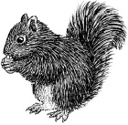
Give ONE feature of the squirrel from the picture.
Describe how this feature helps the squirrel to live in a tree.
Feature of the squirrel that helps it live in a tree: ____________________________
How the feature helps: ________________________________________________
___________________________________________________________________
1 mark

