Class 5 – Homework – Bamburgh & Alnwick 26.9.22
Q1.
Grouping materials
(a) Patrick collects some objects made of different materials.
The photograph below shows what he collects.
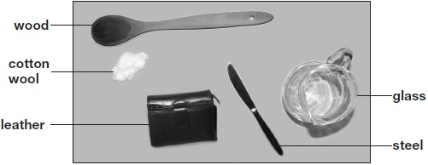
Patrick groups his materials in a diagram to help him sort them by their properties.
Write cotton wool and steel in the correct places on the diagram below.
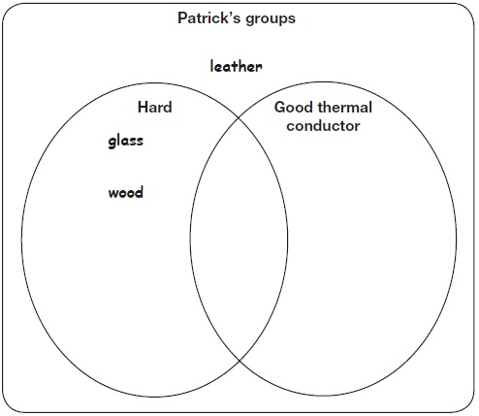
1 mark
(b) The shoes below are used for different activities. They are made out of different materials.
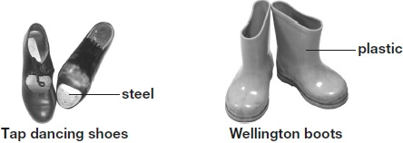
The table below gives a property of steel and explains why this property is useful for tap dancing shoes.
Complete the table below to explain why it is useful for wellington boots to be impermeable.
Material | Shoe | Property | Why the property is useful
steel | tap dancing shoe | hard | it makes a noise when hit
plastic | wellington boot | impermeable | _______________  _______________
1 mark
(c) This tea towel is made of a soft material.
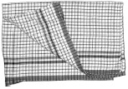
Name TWO other properties of the soft material that make it good to use for a tea towel.
1. _________________________________________________________________
2. _________________________________________________________________
2 marks

Q2.
Lighthouse

(a) | George makes a model lighthouse using a cardboard tube and a yoghurt pot.  He makes a circuit to make his lighthouse light up.  The yoghurt pot lets some light through. | 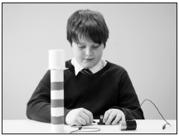
What is the name given to a material that lets only some light through?
___________________________
1 mark
(b) George wants to make his lighthouse have a brighter light.
Tick ONE box to show what George could use instead of a yoghurt pot to make the lighthouse appear brighter.
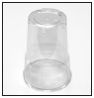 | plastic cup |  | 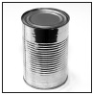 | tin can
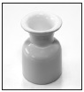 | china egg cup |  | 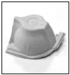 | part of cardboard egg box
1 mark
(c) George uses one bulb, one cell (battery) and two wires to make the circuit for his lighthouse.
Draw the circuit diagram using the correct symbols for the lighthouse.
2 marks
(d) Write true or false next to each sentence about the circuit.

 | George’s circuit will only work if... | True or False?
 | the cell is connected to the bulb. | ____________
 | there are gaps in the circuit. | ____________
 | he uses wires of the same length. | ____________
 | the wires are connected to the same end of the cell. | ____________
2 marks
(e) What component should George add to his circuit to make the light brighter?
___________________________________________________________________
1 mark
Q3.
Pond life
(a) Tom is finding out about pond life. He holds a glass bowl in the water and watches the pond life underneath.
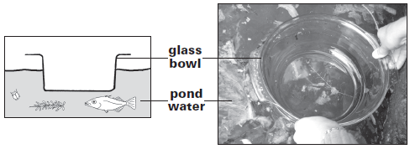
What property of the bowl allows Tom to see the pond life?
The glass bowl is ..................................................................................
1 mark
(b) The pictures below show some of the things Tom sees underneath the bowl.
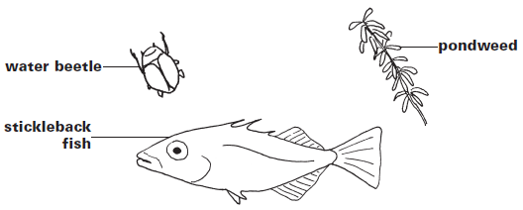
The stickleback fish is a predator.
Tick ONE box to show why the stickleback fish is a predator.
It eats plants. |  | It eats other  animals.
It hides near  pondweed. |  | It gets eaten by  other animals.
1 mark
(c) The pondweed is a producer.
Write true or false next to each of the following statements about producers.
 |  | True or false?
 | Producers are at the start of the food chain. | .............................
 | Producers catch their food from the water. | .............................
 | Producers use sunlight to make new  materials for growth. | .............................
1 mark
(d) | 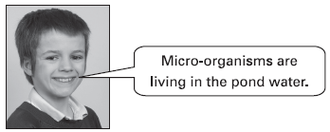
Tom
(i) Explain why Tom cannot see the micro-organisms in the water.
......................................................................................................
1 mark
(ii) Why does it help to have some micro-organisms living in the pond?
......................................................................................................
........................................................................................................

Q4.
Hardness of rocks
(a) Jamila did a scratch test on four different types of rock to see which was the hardest.
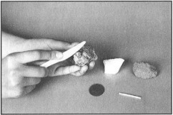
She used four different objects to scratch each rock.
This table shows her results:

Rock | Was scratched by …
 | fingernail | coin | matchstick | plastic knife
marble
sandstone
granite
talc
Which rock could Jamila’s fingernail scratch?
............................................…..
1 mark
(b) Jamila worked out that granite was the hardest rock she tested.
What evidence in the table did Jamila use to find out that granite was the hardest rock she tested?
..............................................................................................................……
…..................................................................................................................
3
1 mark
(c) Use the information in the table.
Write the name of each rock in the boxes below, to show the order of the rocks from softest to hardest.
One has been done for you.
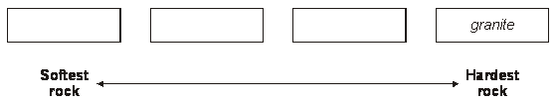
1 mark
(d) As Jamila was doing her test, she realised it was hard to keep her test fair.
Tick ONE box to show why it was hard for Jamila to keep her test fair.

The rocks were different sizes. |  | The shapes of the objects were different.
Some of the objects were harder than others. |  | It was difficult to scratch each  rock with the same force.
1 mark
(e) Jamila carries out some more tests on her rocks. She uses the table below to record the new information she learns from her tests.

 | Permeable | Not permeable
Feels rough | sandstone | granite
Does not feel rough | talc | marble
Use the information from the table to write TWO new things Jamila learnt about granite.
1. .................................................................................................................
2. .................................................................................................................
1 mark

