Class 5 – Homework – Lumley & Raby - 26.9.22
Q1.
Grouping materials
(a) Patrick collects some objects made of different materials.
The photograph below shows what he collects.
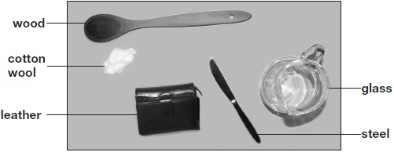
Patrick groups his materials in a diagram to help him sort them by their properties.
Write cotton wool and steel in the correct places on the diagram below.
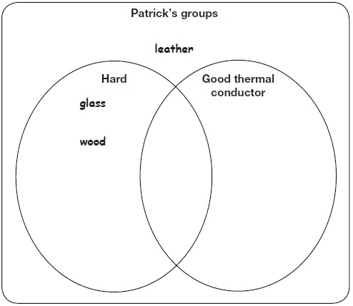
1 mark
(b) The shoes below are used for different activities. They are made out of different materials.
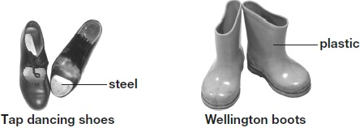
The table below gives a property of steel and explains why this property is useful for tap dancing shoes.
Complete the table below to explain why it is useful for wellington boots to be impermeable.
Material | Shoe | Property | Why the property is useful
steel | tap dancing shoe | hard | it makes a noise when hit
plastic | wellington boot | impermeable | _______________  _______________
1 mark
(c) This tea towel is made of a soft material.
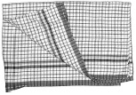
Name TWO other properties of the soft material that make it good to use for a tea towel.
1. _________________________________________________________________
2. _________________________________________________________________
2 marks

Q2.
Lighthouse

(a) | George makes a model lighthouse using a cardboard tube and a yoghurt pot.  He makes a circuit to make his lighthouse light up.  The yoghurt pot lets some light through. | 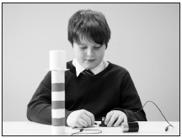
What is the name given to a material that lets only some light through?
___________________________
1 mark
(b) George wants to make his lighthouse have a brighter light.
Tick ONE box to show what George could use instead of a yoghurt pot to make the lighthouse appear brighter.
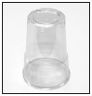 | plastic cup |  | 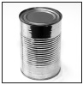 | tin can
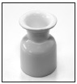 | china egg cup |  | 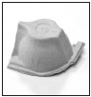 | part of cardboard egg box
1 mark
(c) George uses one bulb, one cell (battery) and two wires to make the circuit for his lighthouse.
Draw the circuit diagram using the correct symbols for the lighthouse.
2 marks
(d) Write true or false next to each sentence about the circuit.

 | George’s circuit will only work if... | True or False?
 | the cell is connected to the bulb. | ____________
 | there are gaps in the circuit. | ____________
 | he uses wires of the same length. | ____________
 | the wires are connected to the same end of the cell. | ____________
2 marks
(e) What component should George add to his circuit to make the light brighter?
___________________________________________________________________
1 mark

