Class 5 – Homework – Lindisfarne - 10.10.22

Solve the calculations below using an appropriate written method to show your workings

1). 37943 + 2471 =
2). 90836 - 5834 =
3). 94582 - 19237 =
4). 830752 + 38045 =
5). 3982.58 - 7389.2 =
Q6.

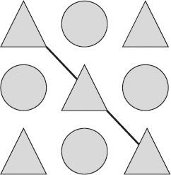
Each shape stands for a number.
The total of the shapes on the diagonal line is 48
The total of all the shapes is 200
Calculate the value of each shape.
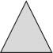 =
1 mark
=
1 mark

Q7.
Jack hires a hall for a party.
This formula is used to work out the total cost.

Total cost = £15 booking fee + £12.50 per hour
What is the total cost of hiring the hall from 6 pm until 11 pm?
1 mark
Q8.
In March, Ken collects 2, 3 or 4 eggs each day from his hens.
In the first 20 days, Ken collects 57 eggs altogether.
There are 31 days in March.
What is the greatest number of eggs Ken can collect in March?

