Class 5 – Homework – Lumley - 10.10.22

Solve the calculations below using an appropriate written method to show your workings

1). 243 + 122 =
2). 1529 - 365 =
3). 3283 - 1208 =
4). 9118 + 3904 =
5). 6130 - 2753 =

Q1.
One table can seat 8 people.
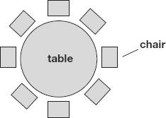
How many tables are needed to seat 40 people?

Q2.
In this grid, there are four multiplications.
Write the three missing numbers.

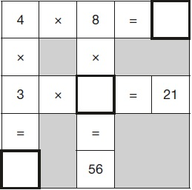

Q3.
Stefan completes this calculation.
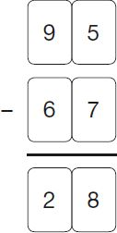
Write an addition calculation he could use to check his answer.
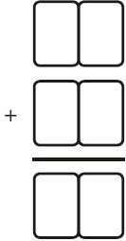
1 mark
Q4.

A pack of paper has 150 sheets.
4 children each take 7 sheets.
How many sheets of paper are left in the packet?

