Class 5 – Homework – Raby & Lumley 17.10.22

Using the materials in the photos below, can you categorise them into reversable or irreversible changes?
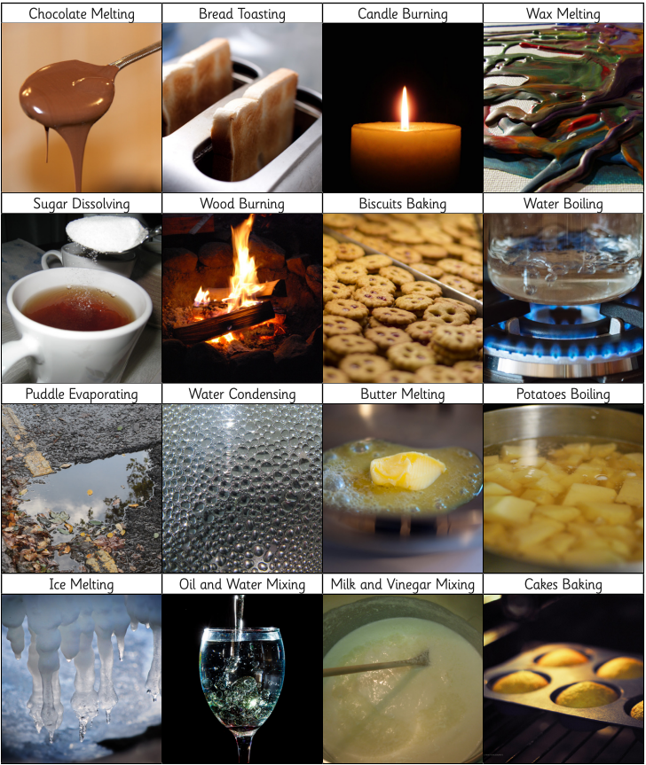
Can you use the table below to classify your materials?

