Class 5 – Homework – Raby - 10.10.22

Solve the calculations below using an appropriate written method to show your workings

1). 35 + 14 =
2). 48 - 26 =
3). 163 + 46 =
4). 153 - 39 =
5). 264 - 232 =

Q1.
Here are six number cards.
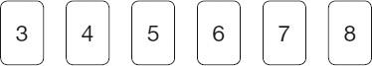
Use all six cards to complete the three multiplications below.
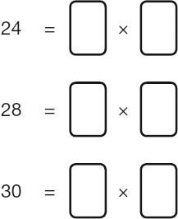
1 mark

Q2.
Olivia buys a banana, an apple and a bag of nuts.

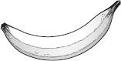 | 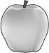 | 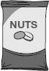
30p | 45p | 60p
She pays with three 50p coins.
What is her change?

2 marks

Q3.
Some children vote for their favourite ice-cream flavour.

Ice-cream flavour | Number of children
vanilla | 87
chocolate | 154
strawberry | ?
mint | 38
Total | 402
How many children vote for strawberry?

