Class 5 – Homework – 17.10.22

Using the materials in the photos below, can you categorise them into reversable or irreversible changes?

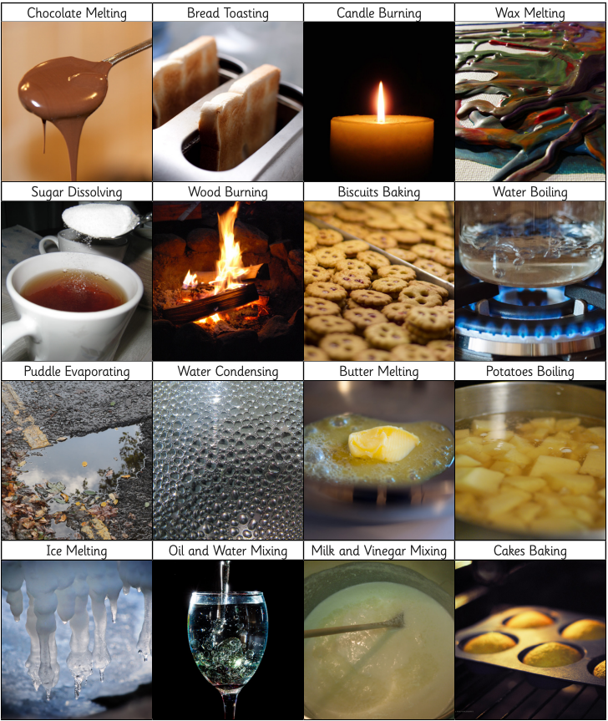
For the reversable changes, can you explain how the change can be reversed?

For the irreversible changes, can you identify the reactant and the products?

Can you use the table below to classify your materials?/

