Class 5 – Homework – Alnwick - 21.11.22
Q1.

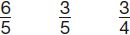
Write these fractions in order, starting with the smallest.
1 mark
Q2.
This is a diagram of a vegetable garden.
It shows the fractions of the garden planted with potatoes and cabbages.

potatoes | cabbages | Not to scale
 | carrots
The remaining area is planted with carrots.
What fraction of the garden is planted with carrots?

2 marks

Q3.

In this circle, and are shaded.
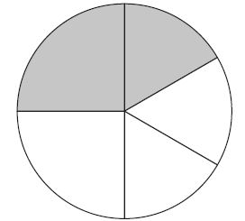
What fraction of the whole circle is not shaded?

2 marks
Q4.

The numbers in this sequence increase by the same amount each time.
Write the missing numbers.
2 marks

Q5.

On Saturday Lara read of her book.
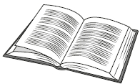
On Sunday she read the other 90 pages to finish the book.
How many pages are there in Lara’s book?

2 marks
Q6.

Write the missing fraction.

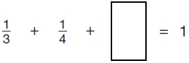
1 mark
Q7.

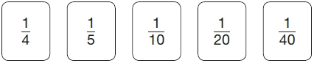
Use three of these fraction cards to complete the sum below.

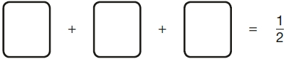
1 mark

Q8.

(a) Write numbers in the boxes to make this fraction calculation correct.
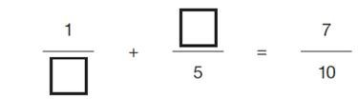
1 mark
(b) Now write two different numbers to make the calculation correct.
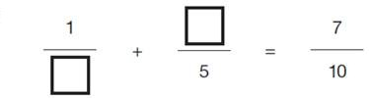
1 mark

