Class 5 – Homework – Bamburgh - 21.11.22
Q1.
In a race, Ali completes a swim, a run and a bicycle ride.
The swim is of the total distance.
The run is of the total distance.
What fraction of the total distance is the bicycle ride?
1 mark
Q2.

Each diagram below is divided into equal sections.
Shade three-quarters of each diagram.
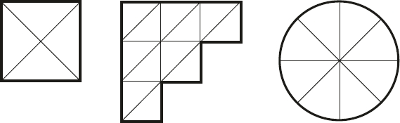
2 marks
Q3.

Here are five diagrams.
Look at each one.
Put a tick (✔) on the diagram if exactly half of it is shaded.
Put a cross (✘) if it is not.

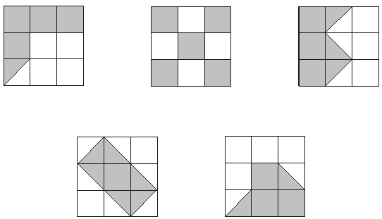
2 marks
Q4.

of this shape.

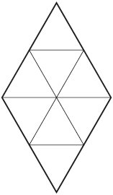
1 mark

Q5.

Circle the two fractions that have the same value.

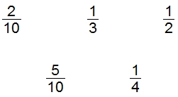
1 mark
Q6.

Circle the two fractions that are greater than
1 mark
Q7.

of a class are boys.
What fraction of the class are girls?
1 mark
Q8.

Write these numbers in order starting with the smallest.

smallest |  |  | largest
1 mark

