Class 5 – Homework – Lindisfarne - 21.11.22

Q1.
Write the missing values.
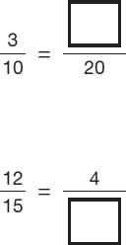
1 mark
Q2.
Tick the fractions less than

2 marks
Q3.
Circle the improper fraction that is equivalent to
1 mark
Q4.

Tick two shapes that have shaded.
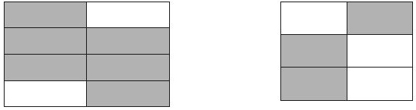
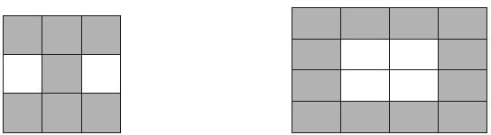
1 mark
Q5.

Write the two missing values to make these equivalent fractions correct.
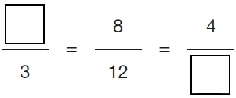
2 marks

Q6.

Here are some shapes made of squares.
A fraction of each shape is shaded.
Match each shape to its equivalent fraction.
One has been done for you.

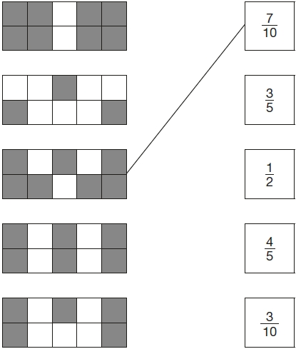
2 marks

Q7.

Tick (✔) each shape that is exactly shaded.

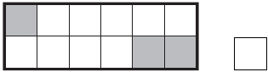

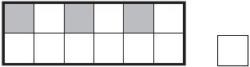
1 mark
Q8.

The diagram is made of squares.
What fraction of the diagram is shaded?

1 mark

