Class 5 – Homework – Lumley - 21.11.22

Q1.

Each of these diagrams is divided into equal parts.
Some of the parts are shaded.

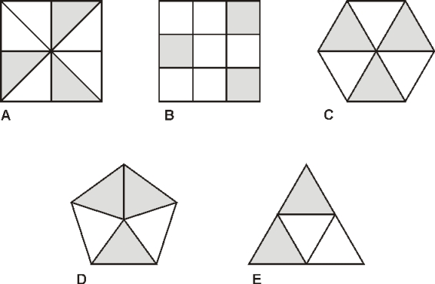
Write the letters of all the diagrams that have exactly shaded.
_________________________
1 mark
Which of the diagrams has exactly shaded?
1 mark

Q2.

Shade of this shape.

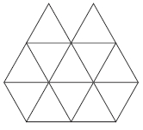
1 mark
Q3.

This diagram shows a shaded rectangle surrounded by squares.

What fraction of the diagram is shaded?
1 mark

Q4.

Sarah has a packet of balloons.

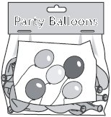
The contents of the packet are
5 red balloons
5 blue balloons
10 yellow balloons
Sarah says,
‘One-quarter of the balloons are red’.
Is Sarah correct?
Circle Yes or No.
Yes / No
Explain how you know.

Q5.

Here is a square.

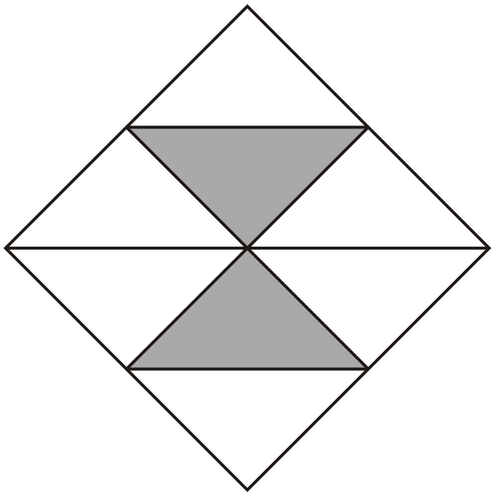
What fraction of the square is shaded?
Q6.

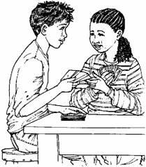
Tom and Nadia have 16 cards each.
Tom gives Nadia 12 of his cards.
How many cards do Tom and Nadia each have now?

Tom |  | Nadia
1 mark
Lucy also has 16 cards.
She gives a quarter of her cards to Kiran.
How many cards does Lucy give to Kiran?
Q7.

Write these numbers in order, starting with the smallest.

0.6 |  | 0.2
smallest |  |  | largest
1 mark

