Class 5 – Homework – Raby - 21.11.22
Q1.
In a race, Ali completes a swim, a run and a bicycle ride.
The swim is of the total distance.
The run is of the total distance.
What fraction of the total distance is the bicycle ride?
1 mark

Q2.
This pictogram shows the number of satellites above the Earth in 2016.
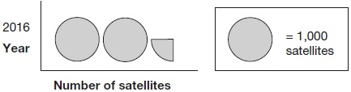
How many satellites were above the Earth in 2016?
1 mark

Q3.
These diagrams show three equivalent fractions.
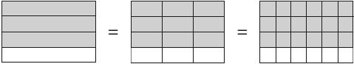
Write the missing values.
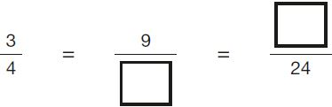
1 mark
Q4.

A fraction of each shape is shaded.
Match each fraction to the correct place on the number line.
One has been done for you.

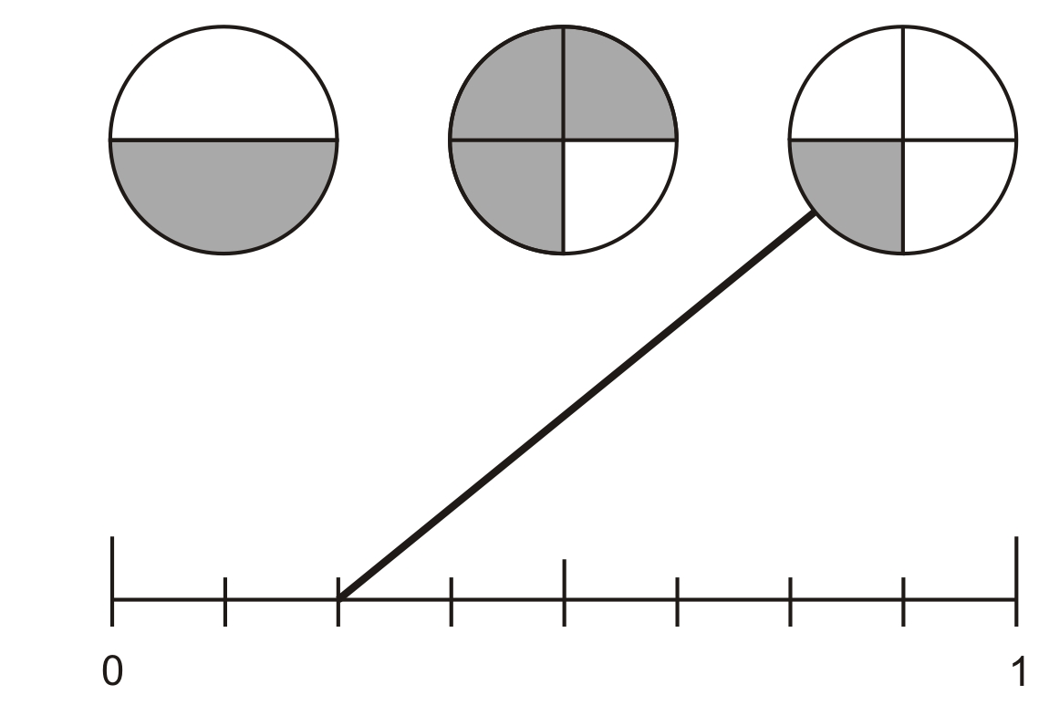
1 mark

Q5.

Meg has 20 pet stickers to go on this page.
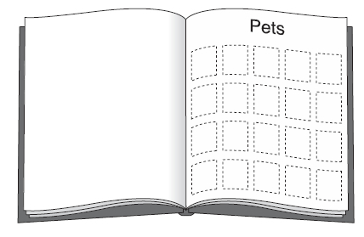
of them are dog stickers.
of them are cat stickers.
The rest are rabbit stickers.
How many rabbit stickers does she have?
Q6.

Jack ate half the cherries on the plate.
These are the cherries that were left.

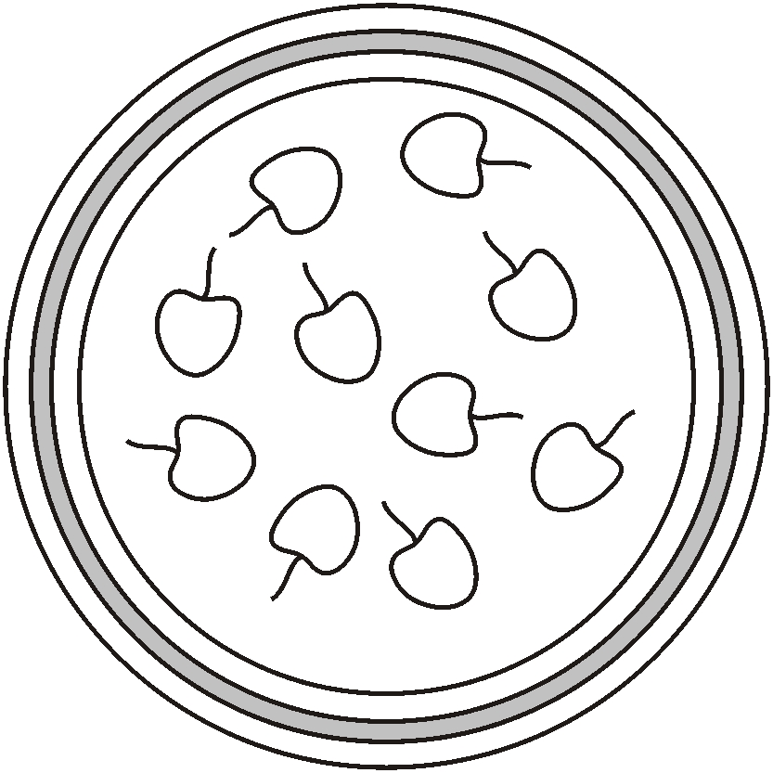
How many cherries were on Jack’s plate before he ate half of them?

