Class 5 – Homework – Alnwick - 28.11.22

Using the chart below, can you plan a healthy diet and exercise for the whole week explaining the impact of your choices.

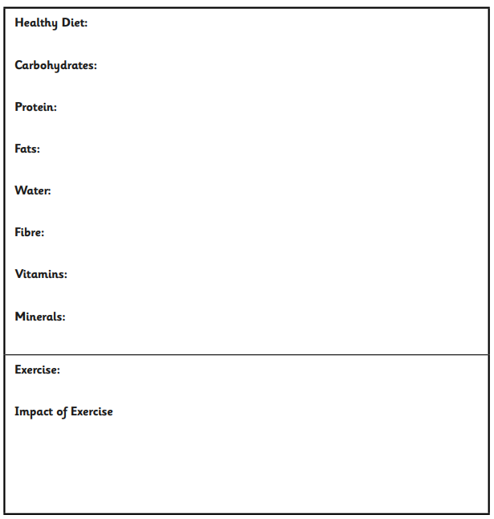

Using your leaflet, can you record all food and drink you have each day, along with the exercise to complete a weekly chart?
Can you discuss your findings?

