Class 5 – Homework – Alnwick – 16.1.23
Q1.
Here is an isosceles triangle inside a rectangle.
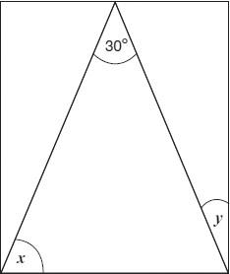
Not to scale
Calculate the sizes of angles x and y.
Q2.

Calculate the size of angles a and b in this diagram.
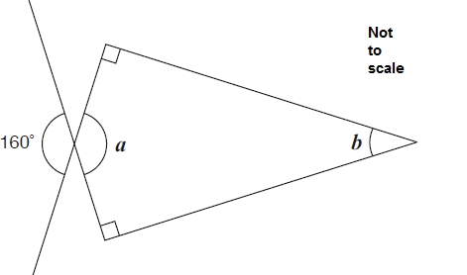
1 mark
1 mark

Q3.

Anna has four different triangles.
Complete the table to show the size of the angles in each triangle.

 | Type of triangle | Angle 1 | Angle 2 | Angle 3
 | Isosceles | 90°
 | Right-angled | 80°
 | Isosceles | 70°
 | Isosceles | 70°
2 marks
Q4.

The diagram shows three identical isosceles triangles.
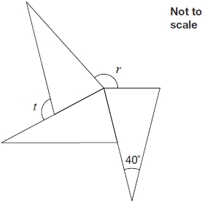
What are the sizes of angles r and t?

2 marks

Q5.

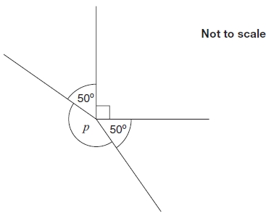
Calculate the size of angle p in the diagram.
Do not use a protractor (angle measurer).

Q6.

The diagram shows an isosceles triangle and a square on a straight line.

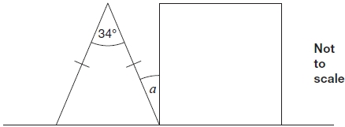
Calculate angle α.

Q7.

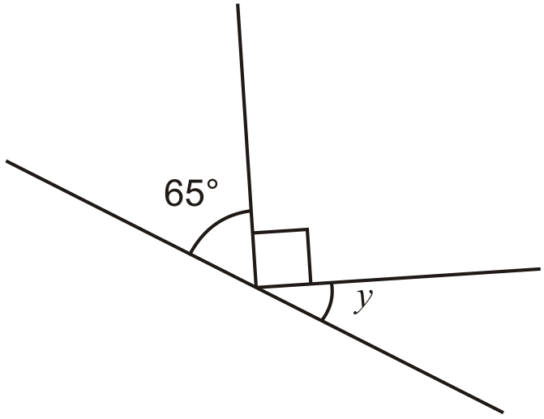
Not to scale
Calculate the size of angle y in this diagram.
Do not use a protractor (angle measurer).
1 mark
Q8.

Here is an isosceles triangle.

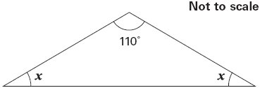
Calculate the size of angle x.
Do not use a protractor (angle measurer).
1 mark

