Class 5 – Homework – Bamburgh – 16.1.23
Q1.

Here are five angles marked on a grid of squares.
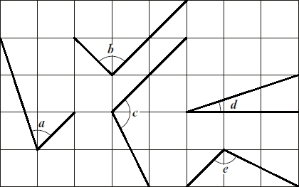
Write the letters of the angles that are obtuse.
________________________
1 mark
Write the letters of the angles that are acute.
________________________
1 mark
Q2.

This diagram has four angles marked A, B, C and D.

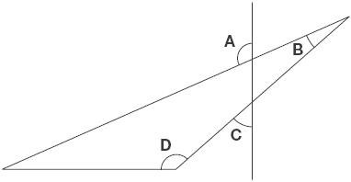
Write the letters of the angles that are obtuse angles.
Q3.

Look at this shape.
Tick (✔) each angle that is less than a right angle.

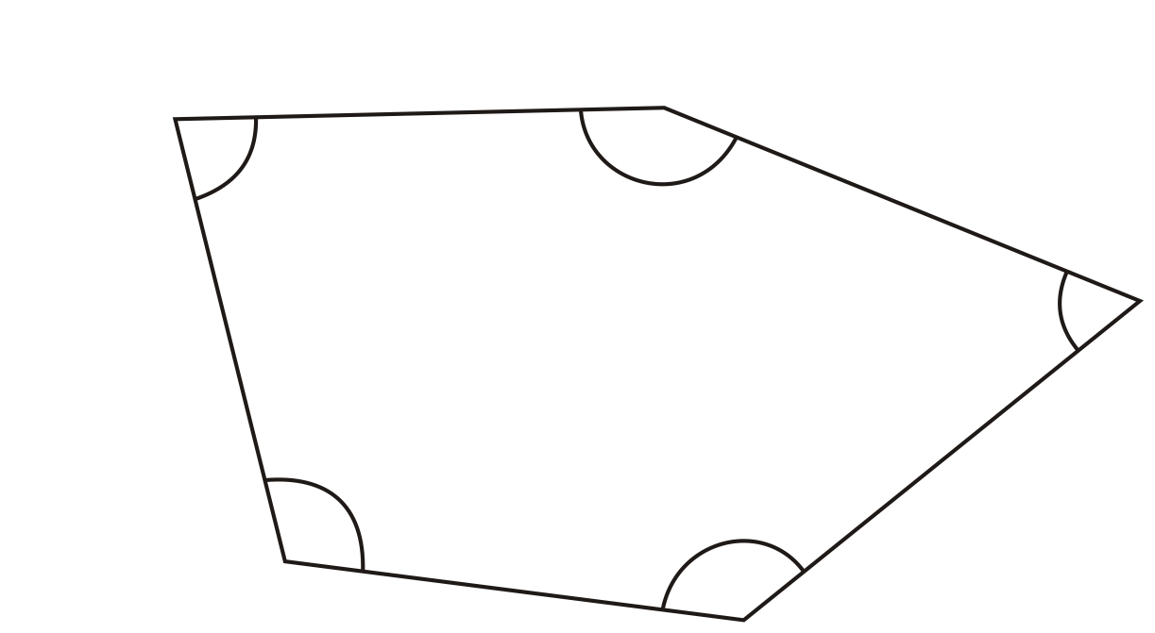
1 mark
Q4.

What will this arrow look like after a half turn?

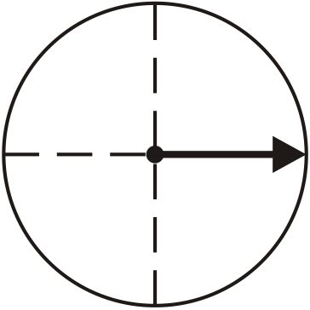
Tick (✔) the drawing a,b,c or d which shows this.

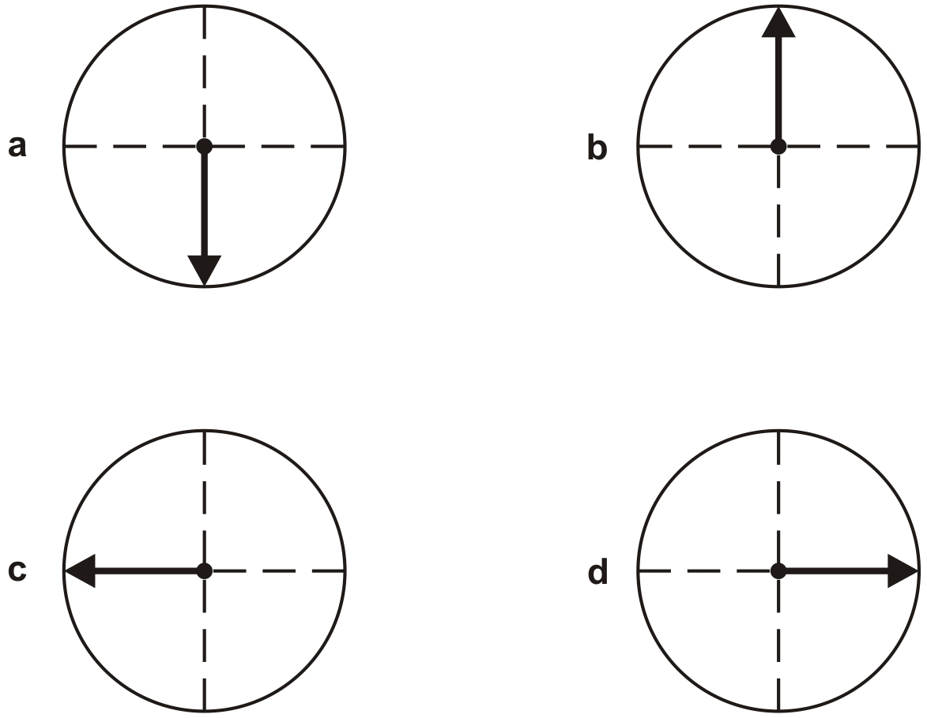
1 mark
Q5.
Look at this shape.
Draw a cross in the corner with the smallest angle.
1 mark

Q6.

Joining points
There are twelve points marked around this circle.
The points are equally spaced. You can join 4 points to make a rectangle.

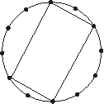
(a) Join 4 points to make a square.

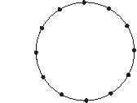
1 mark
(b) Join 3 points to make an equilateral triangle.

1 mark
(c) Join a different set of 3 points to make an isosceles triangle.

1 mark

