Monday 23rd January 2023 – Bamburgh & Alnwick Homework - LIGHT
Q1.
Jack’s shadow
(a) Class 3 are investigating shadows in the playground.
It is a bright sunny day.
Susie measures the length  of Jack’s shadow at 9 am. | 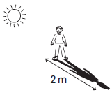
Then she measures the length of Jack’s shadow at midday.
Jack stands in the same position in the playground.
Which picture shows Jack’s shadow at midday? Tick ONE box.
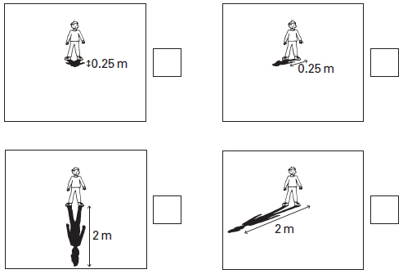
1 mark
(b) Explain why a shadow forms on the ground when the sunlight shines on Jack.
.................................................................................................................
.................................................................................................................
1 mark
(c) At 3 pm Jack stands in the same place in the playground. Susie measures Jack’s shadow again. His shadow has changed position.
What movement in space causes Jack’s shadow to change position?
.................................................................................................................
.................................................................................................................
1 mark
(d) The class observed Jack’s shadow on a sunny day.
Tick ONE box to show why the class should not do their test on a cloudy day.
On a cloudy day...
Jack's shadow is  very dark. |  | Jack's shadow is  difficult to see.
Jack's shadow does  not change position. |  | Jack's shadow is  very big.
1 mark
(e) Susie has some ideas about shadows.
Write true or false under each idea about shadows.
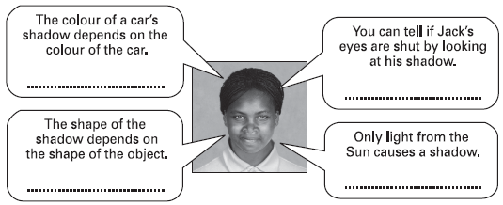
2 marks

Q2.
Shadows and space
(a) Jimmy stands a pole in the playground.
There is a shadow of the pole on the playground.
Why does the pole cause a shadow on the playground?
.......................................................................................................................
1 mark
(b) Jimmy records the shadow at 10 am.
He draws his results on squared paper.
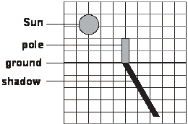
Draw the shadow of the pole at 12 noon.
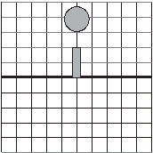
1 mark
(c) Tick ONE box to show which movement in space causes the shadows to change on Earth during a day.
the Sun spinning |  | the Earth orbiting the Sun
the Earth spinning |  | the Moon orbiting the Earth
1 mark
(d) Jimmy and his friends use different sized balls to model the Sun, Earth and Moon.
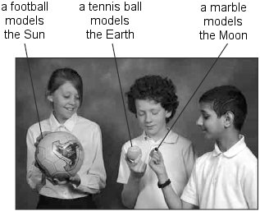
The marble is moved around the tennis ball. 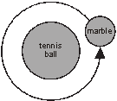
Which movement is modelled by the marble and the tennis ball?
Tick ONE box.
the Moon orbiting  the Earth |  | the Earth orbiting  the Moon
the Moon spinning  on its axis |  | the Earth spinning  on its axis
1 mark
(e) The children use the tennis ball and the football to model an orbit.
This orbit takes one year.
How should the children move the tennis ball and the football to model the orbit that takes one year?
.......................................................................................................................
........................................................................................................................
1 mark

Q3.
Shadows
(a) Lucy makes a shadow of a puppet on a screen.
She investigates how changing the distance of the light from the puppet affects the size of the shadow.
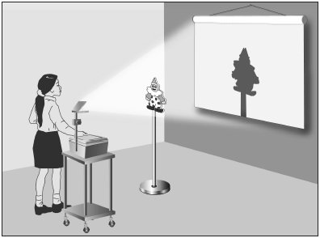
What equipment should she use to measure the distance of the light from the puppet?
......................................................................................................................
1 mark
(b) What unit of measurement should she use to measure the distance of the light from the puppet?
Tick ONE box.
g ºC cm km N
1 mark
(c) What factor should she change as she carries out her test?
Tick ONE box.
where the children sit |  | colour of the screen
brightness of the light |  | position of the light
position of the screen |  | the size of the puppet
1 mark
(d) What factor should she measure to collect her results?
Tick ONE box.
The height of the...

light |  | shadow |  | table
puppet |  | screen |  | reflection
1 mark
(e) What factors must she keep the same as she carries out her test?
Tick THREE boxes.
where the children sit |  | colour of the screen
position of the puppet |  | position of the light
position of the screen |  | size of the puppet
2 marks

