Michael Morpurgo – Kensuke’ Kingdom

Newspaper – Front Page Article

MISSING Child and Dog; off the North-East Coast of Australia in the Coral Sea. Huge Storm and treacherous conditions cause mountainous waves throughout the night…

Your task is to write the Front Page of a newspaper to report the story of the missing child (Michael) and his dog (Stella).

Can you structure your newspaper report using appropriate:
- Headings
- Subtitles
- Columns
- Images
- Captions

Can you use these question prompts to help you?

- Where was the yacht at the time of the disappearance?

- What happened to cause the child to jump over-board?

- Who reported the missing child to the rescue services, and at what time?

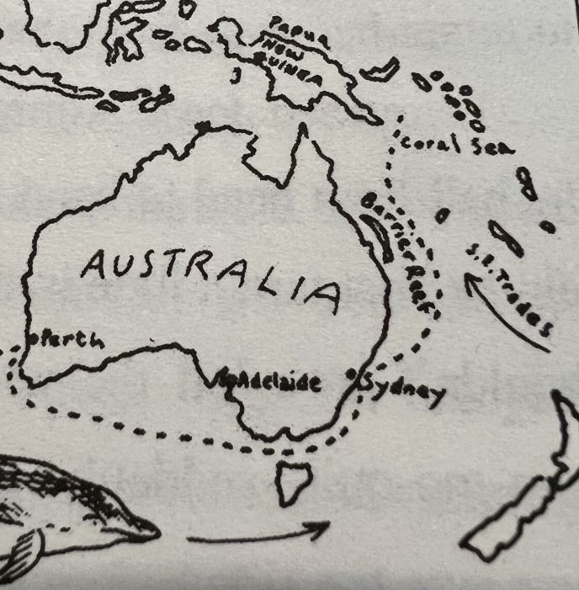
- What will happen next?

