Class 5 – Homework – Lindisfarne – 16.1.23
Q1.

Calculate the size of angles a and b in this diagram.
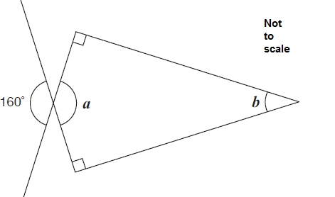
1 mark
1 mark
Q2.

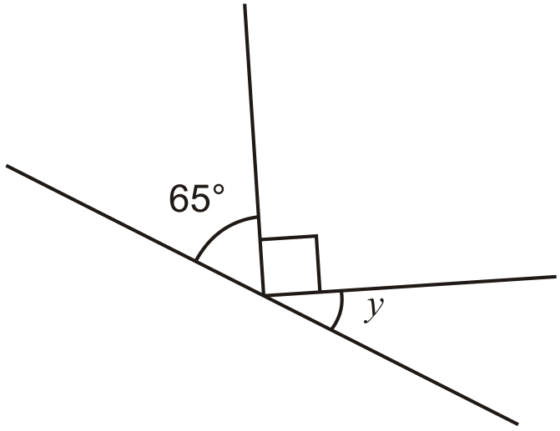
Not to scale
Calculate the size of angle y in this diagram.
Do not use a protractor (angle measurer).

Q3.

The diagram shows a rectangle.

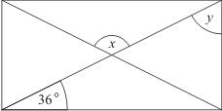
Calculate angles x and y.

2 marks
Q4.

A shaded isosceles triangle is drawn inside a rectangle.

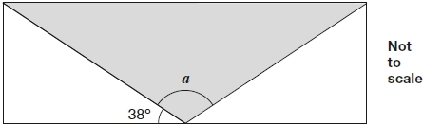
Calculate the size of angle a.

2 marks

Q5.

Join dots on the grid to make a quadrilateral that has 3 acute angles.

1 mark
Q6.

PQ is a straight line.
Not drawn
accurately
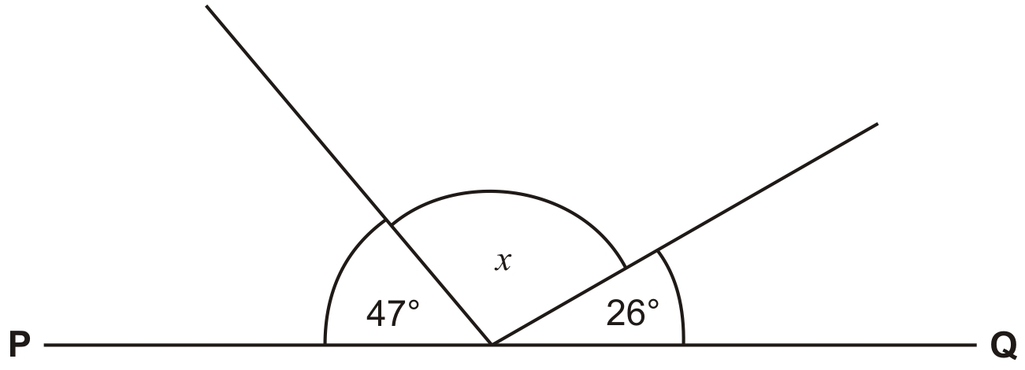
Calculate the size of angle x.
Do not use a protractor (angle measurer).
1 mark

