Monday 23rd January 2023 – Lindisfarne Homework - LIGHT
Q1.
At the dentist
(a) When Jon bites a piece of apple, there is a force from Jon’s teeth on the apple.
(i) Draw ONE arrow on the picture below to show the direction of the force from Jon’s bottom teeth when he bites the apple.
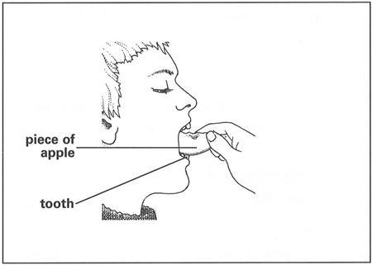
1 mark
(ii) Label the main type of tooth Jon uses to bite the apple.
.........................................................................
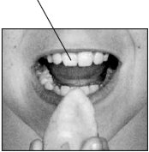
(b) Jon visits the dentist regularly to help stop tooth decay.
Describe ONE other way Jon can help stop tooth decay.
.....................................................................................................................
1 mark
(c) Jon looks around the dentist’s surgery.
He can see the following objects.
Tick ONE box to show which object light passes through best.
mirror |  | glass
pencil |  | coat
1 mark
(d) The dentist uses a lamp to see Jon’s teeth clearly.
Draw TWO arrows on the diagram below to show the direction light travels for the dentist to see Jon’s teeth.
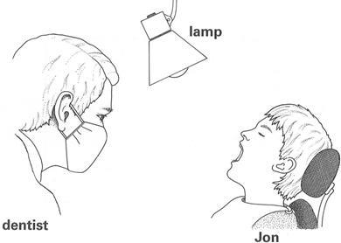
2 marks

Q2.
Light sensor
(a) The light in a classroom comes from different sources.
Tick ONE box below to show one possible source of light in a classroom.
plant |  | mirror
radiator |  | computer screen
1 mark
(b) Some children place a light sensor in the middle of the classroom.
The graph below shows how the light level changed over time.
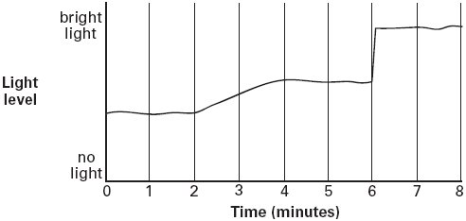
Describe what happened to the light level between two and four minutes on the graph.
......................................................................................................................
1 mark
(c) Describe ONE thing that could have happened in the classroom at six minutes to make the light level suddenly change.
......................................................................................................................
1 mark
(d) The children measure the light above a desk and below a desk.
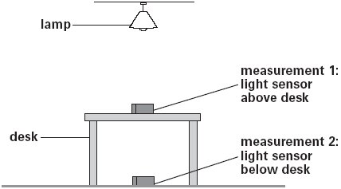
George says: ‘When the light sensor is under the desk, the reading on the sensor goes down.’
Write true or false next to each sentence below.
True or false?
The light source is above the desk. ..............................
The light cannot pass through the desk. ..............................
There is a shadow underneath the desk. ..............................
1 mark
(e) Complete the sentence using a word from the box below.

impermeable opaque transparent solid
The sensor reading is lower when it is below the desk because
the desk is ...................................................
1 mark

Q3.
Light
(a) The things below all make shadows in light.
Draw ONE line from each object to the shadow it could make.
Use each shadow ONCE.
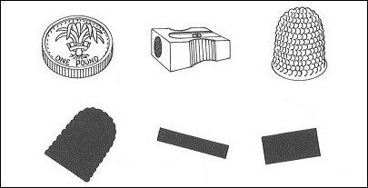
1 mark
(b) Jenny investigates which materials allow light to pass through. She holds different materials out in the sun.
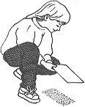
Complete the table below to predict Jenny’s results.
Tick ONE box in each row. One has been done for you.

Material | Some light  passes through | No light  passes through
tissue paper
glass
mirror
clear plastic
cardboard
foil
2 marks
(c) Jenny sits by a lamp.
A shadow forms.
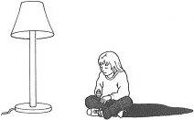
She wants to see if any other objects will cause a shadow in a dark room. She turns the lamp off. She sits in front of these objects instead of the lamp:
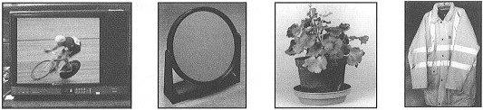
television mirror plant night safety
jacket
(i) Which ONE of these four objects will cause a shadow of Jenny in a dark room?
............................................................................................................
1 mark
(ii) Why does a shadow form when Jenny sits in front of this object?
Tick ONE box.
Because the object...
is translucent. |  | reflects light.
is a light source. |  | is transparent.
1 mark

