Class 5 – Homework – Lumley – 16.1.23

Q1.
Stefan stands in the centre of this square.
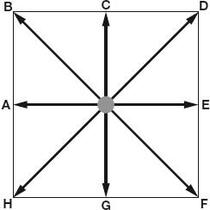
Not actual size
Stefan is facing towards F.
He turns anti-clockwise to face D.
What angle does Stefan turn through?
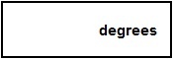
1 mark
Stefan is now facing towards D.
He turns 3 right angles clockwise.
Write the letter he faces after the turn.
________________________
1 mark

Q2.
Kirsty says,
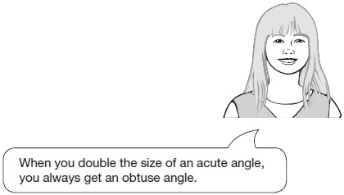
Explain why Kirsty is not correct.

Q3.

Circle the pentagon with exactly four acute angles.
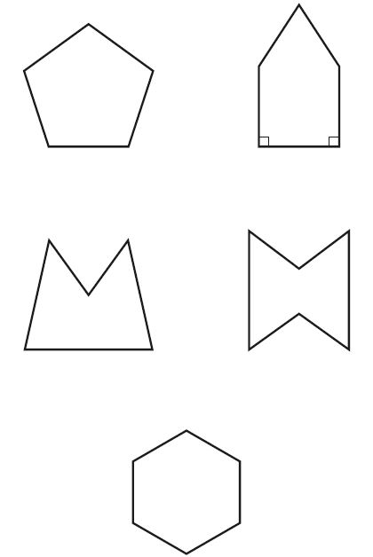
1 mark
Q4.

Here is a grid of dots.
Point A and point B are joined by a straight line.
Draw a line to join point A to another dot on the grid so that the two lines make a right angle.
Use a ruler.

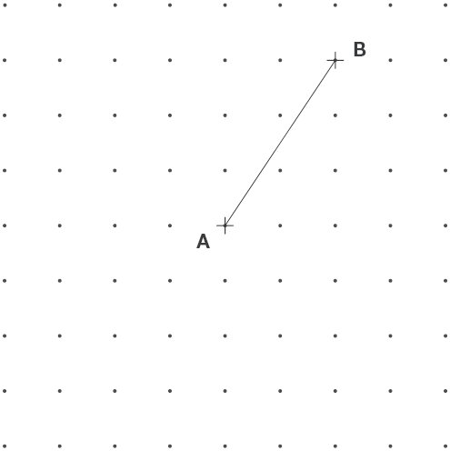
1 mark

Q5.

This shape is three-quarters of a circle.

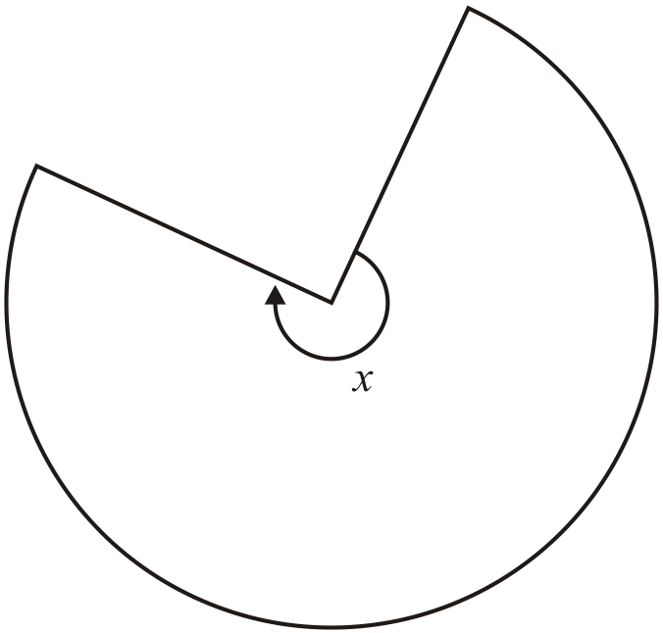
How many degrees is angle x?
1 mark
Q6.
Look at angles a, b, c and d
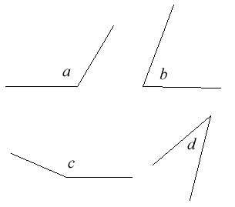
Write the angles in order of size, starting with the smallest.
1 mark

