Monday 23rd January 2023 – Lumley Homework - LIGHT
Q1.
Torch light
(a) Sanna is investigating which materials are good reflectors of light.
She shines a torch on different objects from a distance of 20 cm.
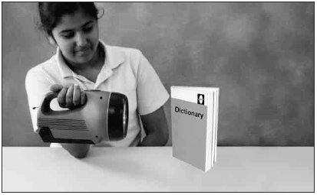
She looks at the objects to see how well each reflects light.
Tick TWO boxes to show which objects are the best reflectors.
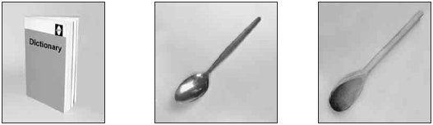
Paper book Metal spoon Wooden spoon

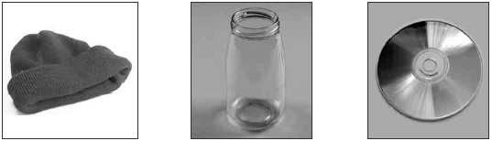
Woolly hat Glass jar Compact disc
2 marks
(b) Tick ONE box to show which of Sanna’s objects does not make a dark shadow.
metal spoon |  | wooden spoon
woolly hat |  | glass jar
1 mark
(c) The picture below shows Sanna looking at the torch light reflected in a mirror.
Draw TWO arrows to show the direction the light must travel for Sanna to see light from the torch in the mirror.
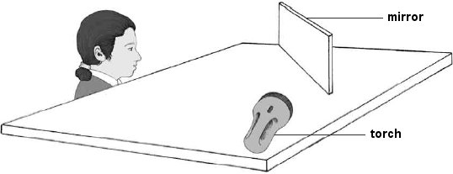
2 marks

Q2.
The Earth and light
(a) Kate and Ashur are finding out about the Earth, Sun and Moon.
They decide to investigate how shadows change at different times of the day. Kate measures the length of Ashur’s shadow.
They repeat their test at two other times of the day.
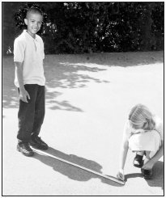
Draw THREE lines to match each time of day to the correct length of shadow.
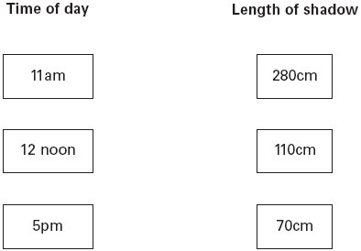
(b) Tick ONE box to show why shadows change length during the day.
The Sun orbits the Earth. |  | The Earth orbits the Sun.
The Sun goes up in the  day and down at night. |  | The Earth spins on its axis.
1 mark
(c) The Moon does not give out light of its own. It reflects light from the Sun.
Tick ONE box to show which sentence below is evidence that the Moon does not give out its own light.
The moon is a sphere but appears to change
shape during the month.
The Moon is nearer to the Earth than the Sun.
The Moon cannot be seen on cloudy days.
The position of the Moon in the sky changes.
1 mark
(d) Draw TWO arrows on the diagram below to show the direction the light travels so that a person on the Earth can see the Moon.
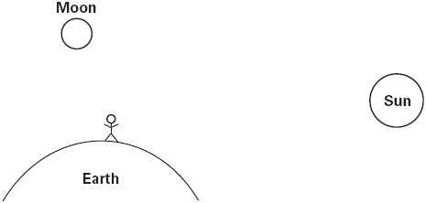
2 marks

Q3.
Puppet show
(a) Emma makes a stick puppet. She draws a face on it.
The puppet has a metal crown. When Emma shines a light on the puppet, the crown looks shiny.
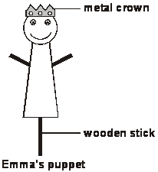
Why does the metal crown look shiny when the light is on it?
......................................................................................................................
......................................................................................................................
1 mark
(b) Draw TWO arrows on the diagram below to show how Emma can see the light shining on the puppet’s crown.
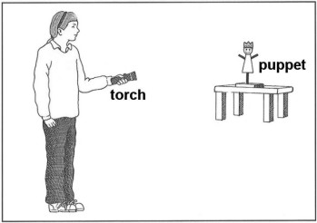
2 marks
(c) When the light shines on the puppet, Emma can see a shadow of the puppet on the wall behind.
Why does a shadow form behind the puppet when the light shines on it?
......................................................................................................................
......................................................................................................................
1 mark
(d) Which of the following shows the correct shadow of Emma’s puppet?
Tick ONE box.
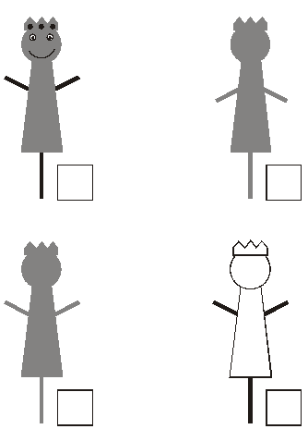
1 mark

