Class 5 – Homework – Raby – 16.1.23
Q1.

Here are two shapes on a square grid.
For each shape, write how many right angles it has.

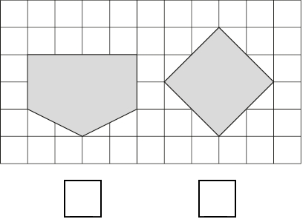
1 mark
Q2.

This diagram shows a square with dots at the vertices and at the middle of each side.
The square is divided into four triangles, A, B, C and D.

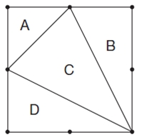
Write the letters of all the triangles that have a right angle.
_________________________
1 mark
Write the letters of all the triangles that have two equal sides.

Q3.

This diagram has four angles marked A, B, C and D.

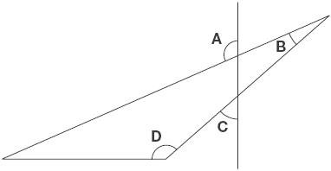
Write the letters of the angles that are obtuse angles.
1 mark
Q4.

Here are five shaded triangles on a square grid.

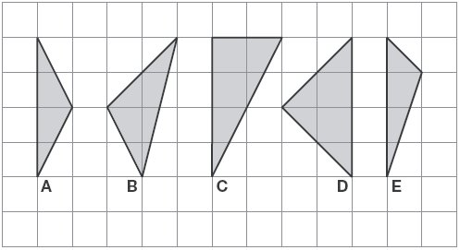
Write the letter of each triangle that has a right angle.
1 mark
Write the letter of each triangle that has two equal sides.
Q5.

Put ticks (✔) and crosses (✘) on the chart to complete it correctly.
One has been done for you.

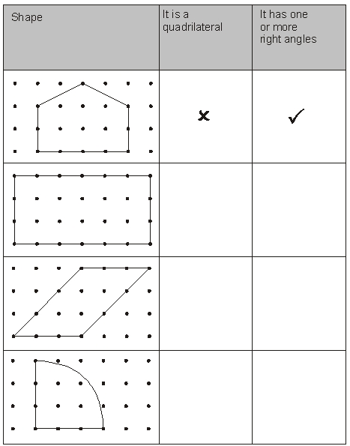
2 marks

Q6.

Complete the table.

shape | number of right angles
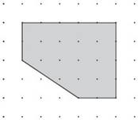
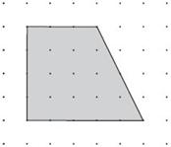
1 mark
Complete the table.
 | property of shape
 | is an  octagon | has at least  1 right angle
shape A | ✘ | ✔
shape B | ✔ | ✘
shape C
shape D |  | ✔
1 mark

