Monday 23rd January 2023 – Raby Homework - LIGHT
Q1.
Shadows
(a) Josh is investigating shadows. He places a block on the floor. He holds a lamp and looks at the shadow the block makes.
(i) Look at the pictures below.
Which picture shows the correct length and direction of the shadow made by the block?
Tick one.
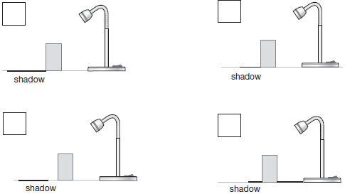

1 mark
(ii) Why does a shadow form when Josh shines the light on the block?
Tick one.
The block is grey and shiny.
The block is smooth and rigid.
The block is solid and opaque.
The block is hard and transparent.
1 mark

(b)
Josh investigates if the distance he puts the lamp from the block affects the length of the shadow on the floor.  Josh records his results in the table below. | 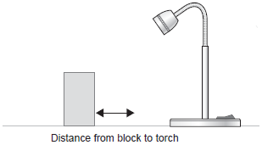

Distance of lamp  from block (cm) | Length of block's  shadow (cm)
5 | 7
10 | 9
15 | 12
20 | 14
25 | 17
Describe the relationship between the distance of the lamp from the block and the length of the shadow.
1. ...................................................................................................................
2. ....................................................................................................................
1 mark
(c) Josh found out that the distance of the lamp from an object does affect how long the shadow is.
He wants to find out more about how to change shadow size.
Suggest another investigation that Josh could carry out using the same lamp and block to find out more about how the size of a shadow changes.
1. ...................................................................................................................
2. ....................................................................................................................
1 mark

Q2.
Torch light
(a) Sanna is investigating which materials are good reflectors of light.
She shines a torch on different objects from a distance of 20 cm.
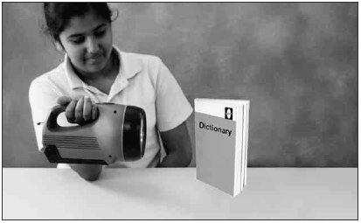
She looks at the objects to see how well each reflects light.
Tick TWO boxes to show which objects are the best reflectors.
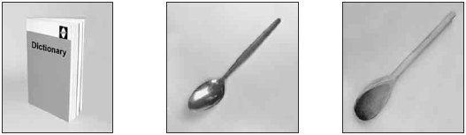
Paper book Metal spoon Wooden spoon

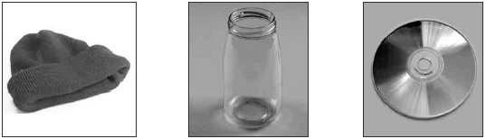
Woolly hat Glass jar Compact disc
2 marks
(b) Tick ONE box to show which of Sanna’s objects does not make a dark shadow.
metal spoon |  | wooden spoon
woolly hat |  | glass jar
1 mark
(c) The picture below shows Sanna looking at the torch light reflected in a mirror.
Draw TWO arrows to show the direction the light must travel for Sanna to see light from the torch in the mirror.
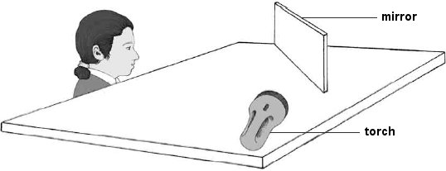
2 marks

Q3.
Light
(a) Ian shines a torch onto some objects to see what happens to the light.
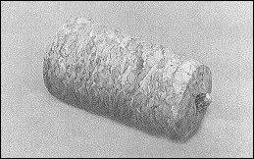
tracing paper bottle cork
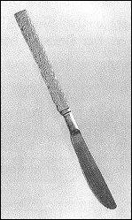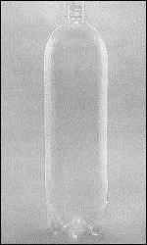
metal knife clear plastic bottle
Write the name of ONE object to complete each of these sentences.
Only use the name of an object once.
(i) The light went through the ................................................................ .
(ii) The light made the ............................................................ look shiny.
(iii) The light made the ........................................... make a dark shadow.
1 mark
(b) Ian has made a periscope with two mirrors and some card.
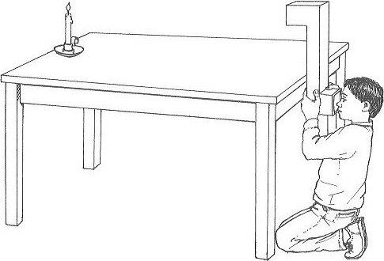
Periscopes let you see over the top of things.
Ian can see the candle by looking through the periscope.
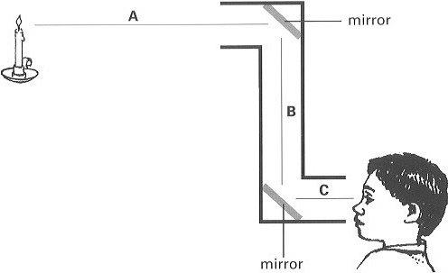
Show the directions light travels to allow him to see the candle.
Draw ONE arrowhead on EACH of the lines A, B and C.
1 mark

