Class 5 – Homework – Alnwick – 6.2.23
Q1.

Megan says,
‘If two rectangles have the same perimeter,
they must have the same area.’
Is she correct?
Circle Yes or No.
Yes / No
Explain how you know.

1 mark
Q2.

Here is a T-shape made from 3 identical rectangles.
The area of the T-shape is 90 cm²

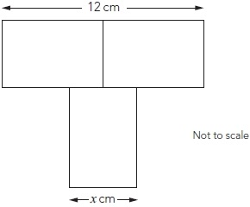
Work out the value of x

2 marks

Q3.

The grid below is made of right-angled  triangles like this: | 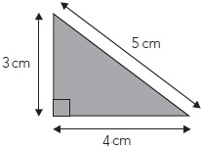
Shade triangles on the grid to make a quadrilateral.
Your quadrilateral must have an area of 24 cm^{2 and a perimeter of 26 cm.}

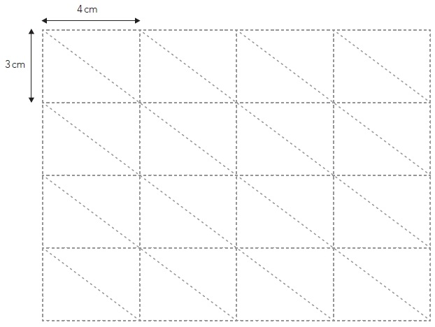
2 marks

Q4.

Twelve rectangles, all the same size, are arranged to make a square, as shown in the diagram.

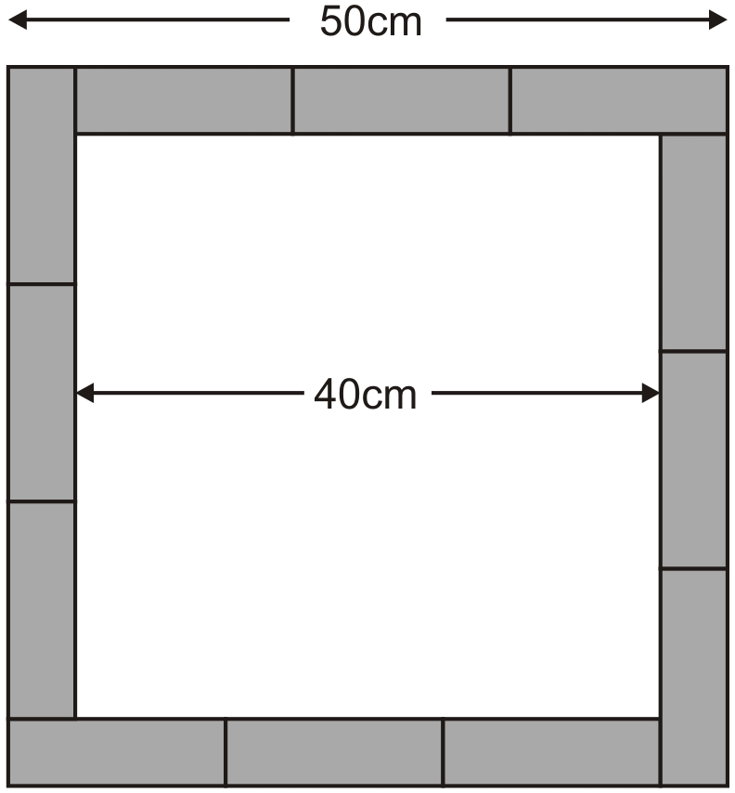
Calculate the area of one of the rectangles.

2 mark

Q5.

The diagram shows a shaded triangle inside a larger triangle.

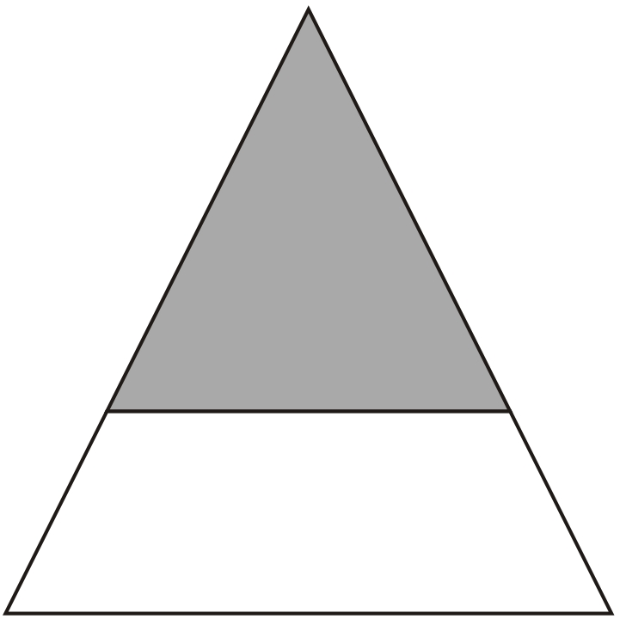
The area of the shaded triangle is 52 cm².
The area of the shaded triangle is of the area of the larger triangle.
Calculate the area of the larger triangle.

2 mark

