Class 5 – Homework – Bamburgh – 6.2.23
Q1.

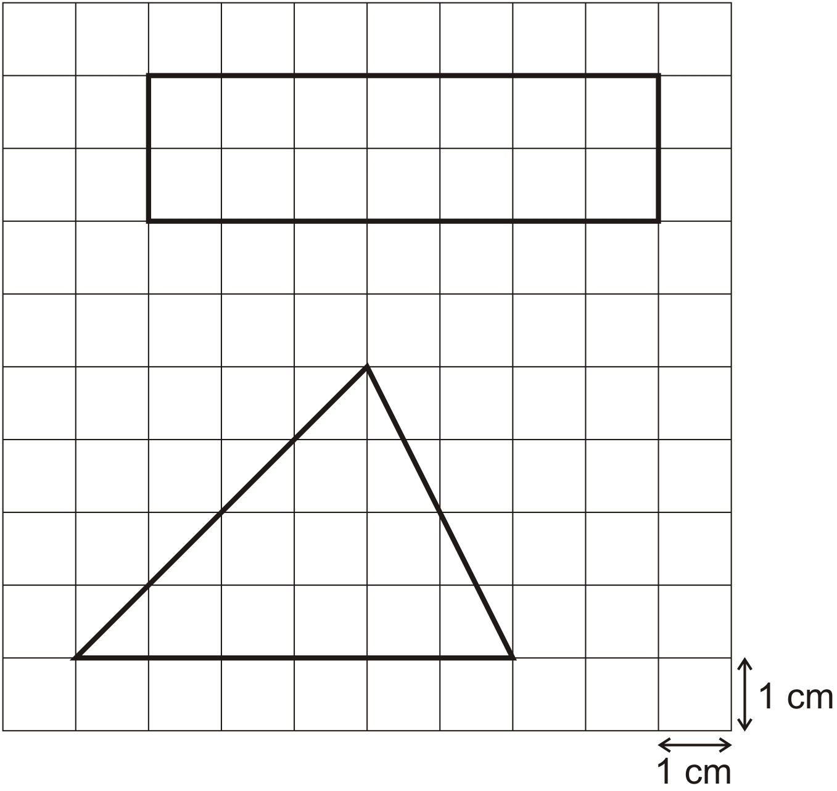
Work out the area of each shape.
(a) Rectangle

1 mark
(b) Triangle
1 mark

Q2.

This ring is made of regular pentagons, with sides of 5 centimetres.

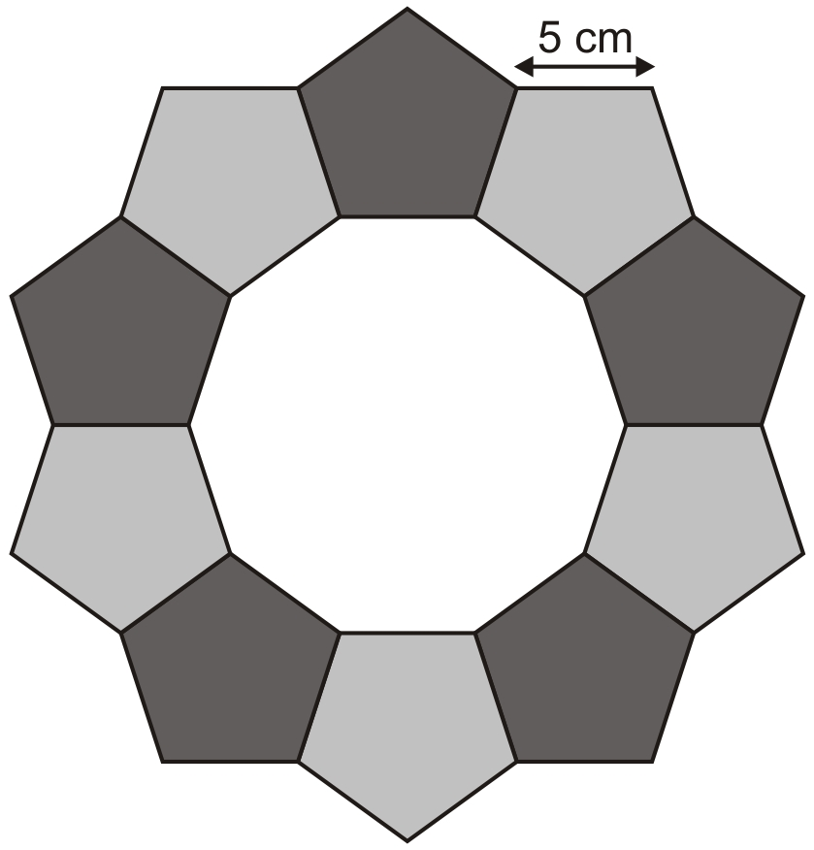
What is the length of the outer edge of the ring?
1 mark
Here is part of a new ring.
It is made of squares and triangles.

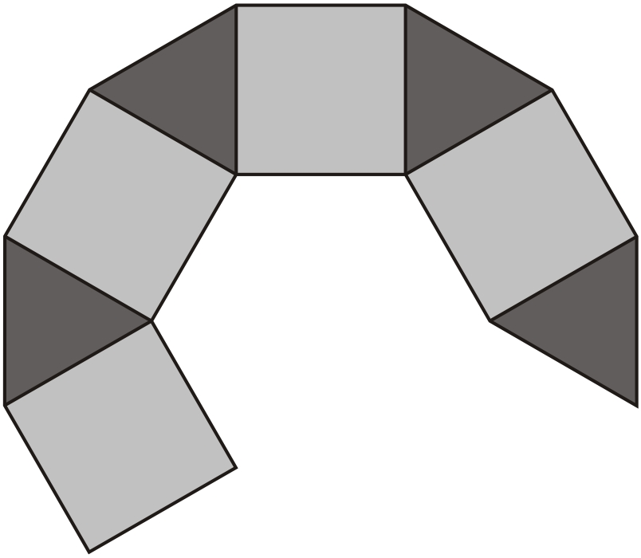
The pattern is continued to complete the ring.
What is the total number of squares used in the complete ring?

Q3.

A line starts at A and goes along the dotted lines to B.
It divides the area of the grid into halves.

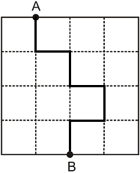
Divide the area of the grid below into halves. Start at A and go along the dotted lines to B.

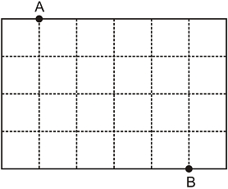
1 mark
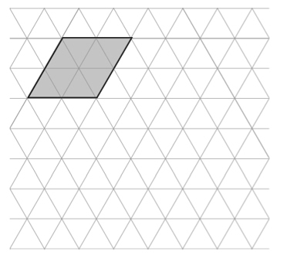
Q4.
Here is a rhombus on a triangular grid.
Draw a different shape with the same area on the grid.

Q5.

Here is a map of an island.
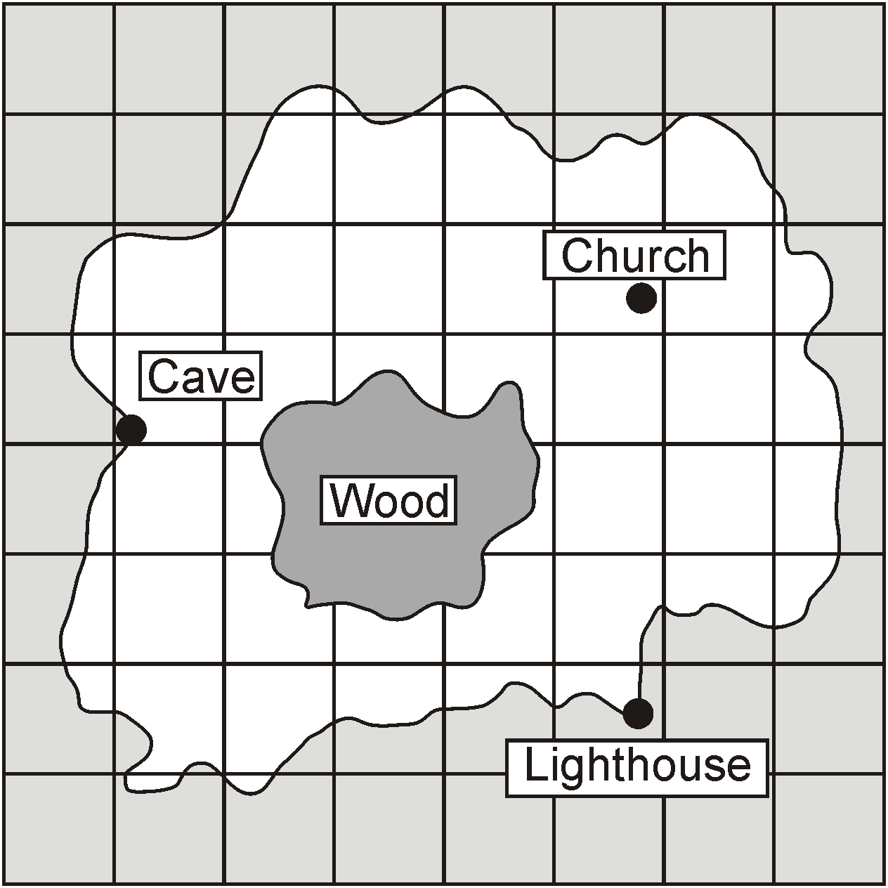
Estimate the area of the Wood.
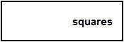
1 mark
A boat can safely carry 145 kilograms.

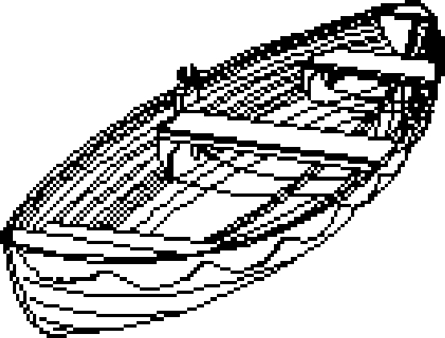
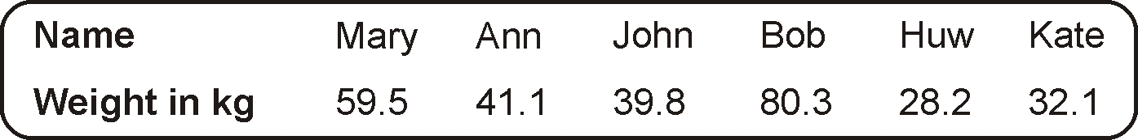
Work out if the boat can safely carry Mary and Bob.
You must show your working.

