Class 5 – Homework – Lindisfarne – 6.2.23
Q1.
These two shapes have the same perimeter.
regular hexagon square
Not actual size
The length of each side of the hexagon is 8 centimetres.
Calculate the area of the square.
2 marks

Q2.

A square tile measures 20 cm by 20 cm.
A rectangular tile is 3 cm longer and 2 cm narrower than the square tile.
What is the difference in area between the two tiles?
3 marks

Q3.

Draw a rectangle on the grid that has half the area of the shaded triangle.
Use a ruler.

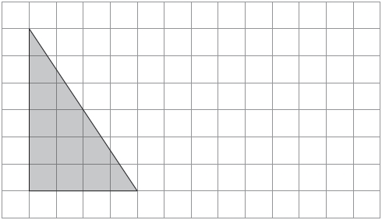
Q4.

The area of this square is 36 cm².

The square is cut into quarters to create 4 identical rectangles.

What is the perimeter of one of the small rectangles?
Q5.

Here is a grid of regular hexagons.
The shaded shape has an area of 3 hexagons and a perimeter of 14 cm.
Draw another shape on the grid which has an area of 4 hexagons and a perimeter of 14 cm.

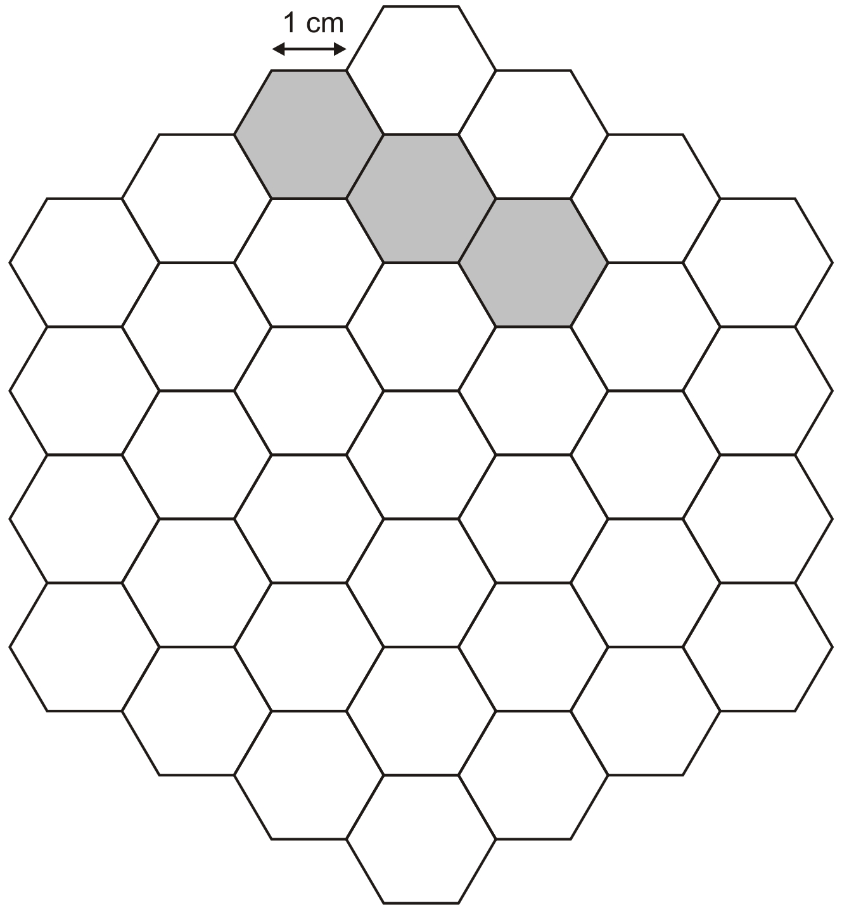
1 mark

