Class 5 – Homework – Lumley – 6.2.23
Q1.

Here is a shaded shape on a 1 cm square grid.
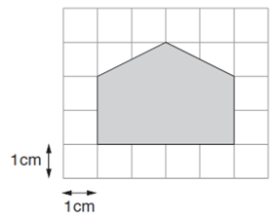
What is the area of the shaded shape?
1 mark

Q2.

Lara has some identical rectangles.
They are 7 centimetres long and 2 centimetres wide.

She uses five of her rectangles to make the large rectangle below.

What is the perimeter of the large rectangle?
1 mark
What is the area of the large rectangle?
1 mark

Q3.

Draw one line from each shape to the rectangle which has the same area.
One is done for you.

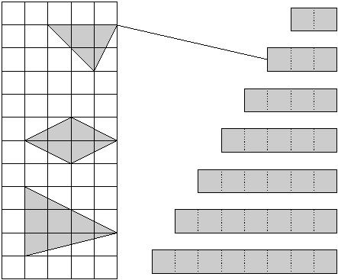
2 mark
Q4.

Here are some shapes on a grid.
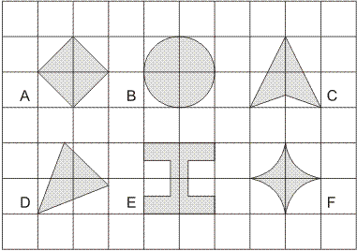
Which shape has the longest perimeter?
1 mark
Which shape has the largest area?
1 mark
Q5.

Here is a centimetre square grid.
On the grid draw a shape which has an area of 10 square centimetres.

1 mark
On the grid below draw a rectangle which has a perimeter of 10 centimetres.

1 mark

