Name:_______________________ Monday 27th February 2023
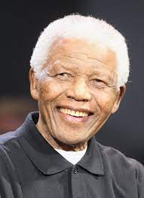
Class 5 Homework – Nelson Mandela

Nelson Mandela
Nelson Mandela was a tireless campaigner for equality and justice who spent 27 years in prison for his beliefs.
In 1994 he became the first president of South Africa to be elected by all the people, black as well as white. He worked to take apart the old racist system of government and to make South Africa a fair society for all its citizens.
He was awarded the Nobel Peace Prize and 250 other awards for his bravery and courage.
- Do you know what makes this man famous?
- Why is he important?
- Where did this man have this greatest impact?
- When do you believe he might have lived?

Your homework this week is to create a portfolio for Nelson Mandela and try to include as many interesting facts about his fascinating work.

