Class 5 – Homework – Raby – 6.2.23
Q1.

Here is a set of 20 squares around a shaded space.

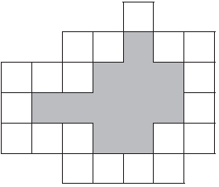
What is the area of the shaded space?
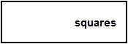
1 mark

Q2.

Lara has some identical rectangles.
They are 7 centimetres long and 2 centimetres wide.

She uses five of her rectangles to make the large rectangle below.

What is the perimeter of the large rectangle?
1 mark
What is the area of the large rectangle?
1 mark

Q3.

Here is a 1cm square grid.
Some of the grid is shaded.

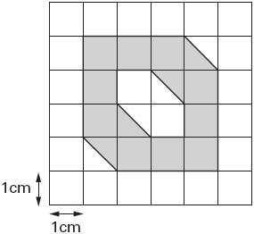
What is the area that is shaded?
1 mark
Q4.
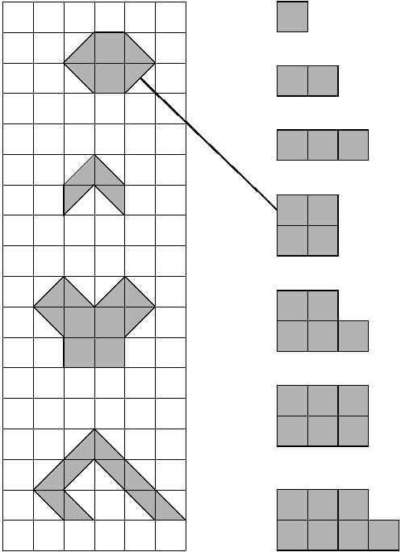
Match each shape on the left to one with equal area on the right.
One has been done for you.

Q5.

On the grid, draw a rectangle which has the same area as this shaded pentagon.
Use a ruler.

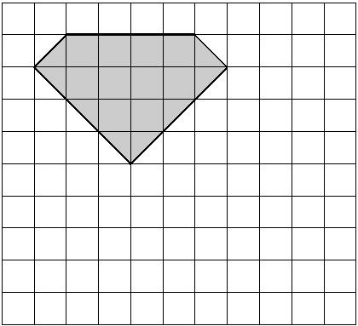
1 mark

