Monday 13th March 2023 – Alnwick Homework – LIVING THINGS
Q1.
In the garden
(a) Fiona is in the garden. She wonders how she can find out the names of some of the plants.
Tick ONE box to show how Fiona could find out the names of the plants.
Fiona could use a...

food chain. |  | producer.
fair test. |  | key.
1 mark
(b) Fiona sorts the plants into groups to help her find out their names.
The plants in one of her groups all have yellow flowers.
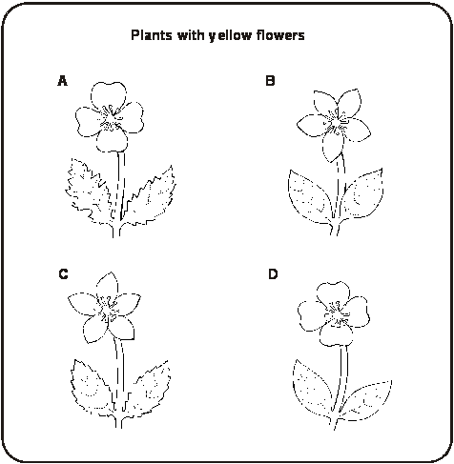
Look at the group of plants with yellow flowers.
Fiona needs to sort these plants into two groups.
(i) Suggest a way these plants with yellow flowers could be sorted into two groups.
Group 1: Plants with yellow Group 2: Plants with yellow
flowers and ........................... flowers and ...........................
................................................ ................................................
(ii) Write A, B, C or D in each box below to show how Fiona should sort the plants with yellow flowers into the two groups you gave above.
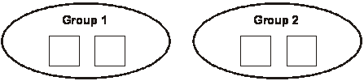
2 marks
(c) Scientists sort plants into groups.
Tick ONE box to show why it is a good idea.
to compare plants with animals
to see if a plant is a living thing
in case a plant dies
because there are many types of plant
1 mark
Q2.
Penguins
(a) The key below can be used to identify penguins. 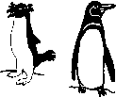
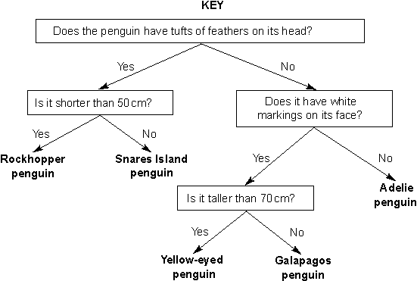
Use the key to identify the penguin below.
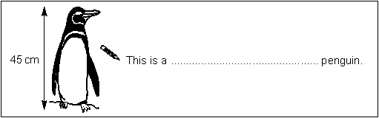
1 mark
(b) Tick ONE box to show the best reason for identifying animals.
so you can find out what  scientific group they are in |  | so you can compare  them with plants
so you can learn about  the country they live in |  | so you can measure  how tall they are
1 mark
(c) Look at the part of the penguins’ food chain below.
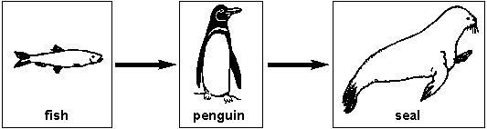
(i) Tick ONE box to show which life process the food chain shows.
movement |  | nutrition
growth |  | reproduction
1 mark
(ii) A fish is not a producer.
Explain why a fish cannot be a producer.
..............................................................................................................
..............................................................................................................
1 mark
(d) Give ONE feature of a penguin and describe how it helps a penguin to live in its environment.
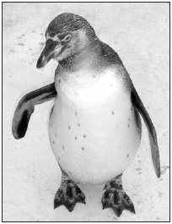
Feature: ...................................................
How the feature helps: ...................................................................................
1 mark
Q3.
Mini-beasts
(a) Some children find four mini-beasts.
They make a table about their observations.
Complete Table 1 below by adding the names of these four mini-beasts.
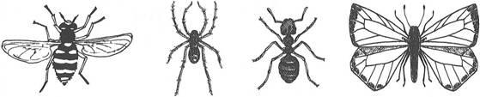
hoverfly spider ant butterfly
Table 1

Name | Legs | Wings | Antennae
................................................... | 6 | 4 | 2
................................................... | 6 | 2 | 2
................................................... | 6 | 0 | 2
................................................... | 8 | 0 | 0
1 mark
(b) The children have some ideas about where to put the mini-beasts when they have finished studying them.
Tick ONE box to show where the children should put the mini-beasts.
in a safe place  away from the road |  | in a pot with food  and water
in the place where  they were found |  | in a dark place  under a log
1 mark
(c) The children find more mini-beasts and make a new table.
Table 2
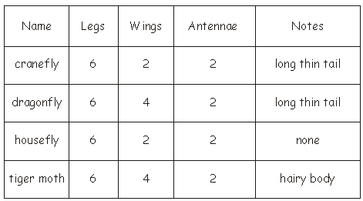
Use Table 2 to help you name these two mini-beasts.
(i) ...................................... (ii) ......................................
1 mark
(d) It would be easier to name the mini-beasts if the children made a key.
Tick TWO boxes to show which features would be useful in a key to separate the four mini-beasts in Table 2.
Tick TWO boxes.
has 6 legs |  | has a long thin tail
has 4 wings |  | has 2 antennae
1 mark

