Monday 13th March 2023 – Lindisfarne Homework – LIVING THINGS
Q1.
Trees
(a) Class 6 are investigating trees in their school grounds.
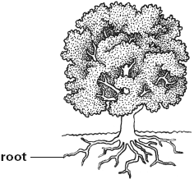
Describe ONE function of the roots.
........................................................................................................................
1 mark
(b) Tree leaves absorb light from the Sun.
Tick ONE box to show the life process for which leaves absorb light.
reproduction |  | nutrition
movement |  | germination
1 mark
(c) The children observe the flowers on some of the trees.
Complete the labels to name the parts of flower A on the diagram below.
2 marks
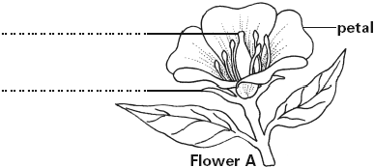
(d) Here are the children’s observations of flower B:

The flower does not have a smell.  It does not have bright petals.  It has lots of long stamens. | 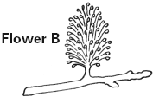
Tick ONE box to show how flower B is pollinated.
Use the children’s observations to help you.
by insects |  | by birds
by wind |  | by humans
1 mark
(e) The table below can be used to sort the flowers on the trees.
Write all the names of the flowers in the correct boxes on the sorting diagram. One has been done for you.
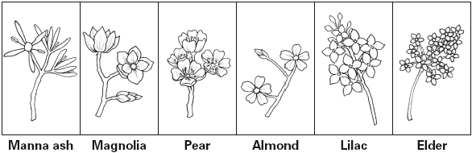
 | Flower has  five petals | Flower does not have  five petals
Flowers are  grouped together  on the stem |  | Manna ash
Flowers are
spread out along
the stem
2 marks

Q2.
Butterfly garden
(a) This diagram shows the life cycle of a red admiral butterfly.
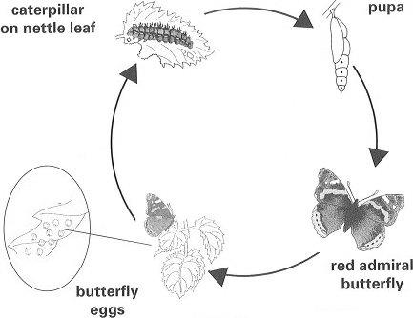
John wants to get rid of all the nettles in the school wildlife area.
This will affect the red admiral butterfly.
Give TWO different reasons why nettle plants are important in the life cycle of the red admiral butterfly.
(i) ............................................................................................................
1 mark
(ii) ............................................................................................................
1 mark
(b) Some birds eat caterpillars.
Use the diagram to help you complete the food chain below.
.......................... ............................
8
1 mark

Q3.
Blackbirds
(a) Some children watched a video about blackbirds and their young.
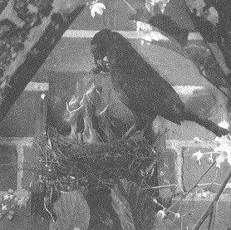
They used the video to make a diary.
Read the information in the diary carefully.
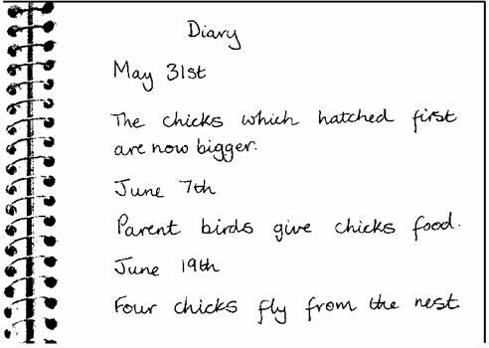
Tick THREE things all animals do.
sing |  | grow
feed |  | fly
lay eggs |  | reproduce
3 marks
(b) Look at the diary.
Write down the evidence from the diary that shows that chicks grow after they have hatched.
......................................................................................................................
......................................................................................................................
1 mark
(c) The children found some information about birds' eggs.
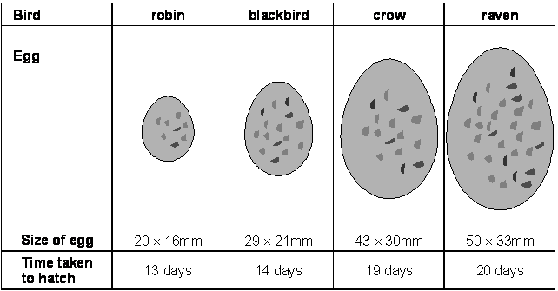
Describe the pattern between the size of these eggs and the time taken to hatch.
......................................................................................................................
......................................................................................................................
2 marks

