Monday 13th March 2023 – Lumley Homework – LIVING THINGS
Q1.
Penicillin
(a) In 1928 a scientist called Alexander Fleming grew micro-organisms called bacteria. Growth shows that bacteria are living things.
The bacteria grew on agar (jelly) in glass dishes.
After a few days Fleming saw mould growing in one of the glass dishes.
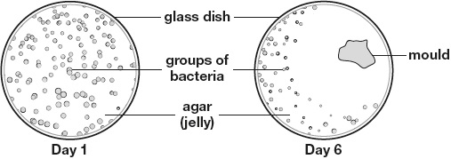
(i) Sort the five things in the box below into living and non-living things.
One has been done for you.

bacteria glass dish mould agar (jelly) human

 | Living things | Non-living things
 | bacteria
1 mark
(ii) Growing is a life process.
Name ONE other life process.
______________________________________________________________
1 mark
(b) Bacteria can cause disease.
Fleming thought he could use the mould to help cure disease caused by bacteria.
Look at the pictures above for Day 1 and Day 6.
Use the evidence in the pictures to explain why Fleming thought the mould could be used to cure disease.
___________________________________________________________________
___________________________________________________________________
1 mark
(c) Fleming used the mould to make a medicine called penicillin.
It took over 10 years for penicillin to be first used by doctors.
Write true or false next to each statement to show why it took a long time for penicillin to be used as a medicine.

 |  | True or False?
 | The medicine had to be tested to make sure it was safe. | ____________
 | Scientists had to find a way of making lots of penicillin at a time. | ____________
 | It took 10 years for the mould to start growing. | ____________
 | Fleming needed to check that his ideas were correct. | ____________
2 marks
Q2.
Germinating seeds
(a) Sunita wants to find out if some types of seed germinate more quickly than others.
Sunita plants her seeds in seed trays.
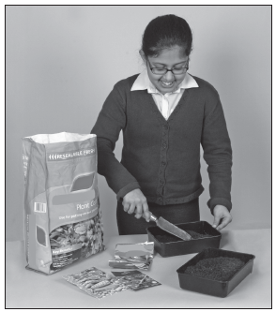
Name the ONE variable Sunita is changing in her investigation.
.................................................................................................................
1 mark
(b) Sunita needs to make sure her investigation is fair.
Name TWO variables Sunita should keep the same to make her investigation fair.
1 ..............................................................................................................
2 ..............................................................................................................
1 mark
(c) When a seed germinates, a root starts to grow before a shoot.

Sunita measures which type of seed  germinates first by recording  when she first sees the shoot. | 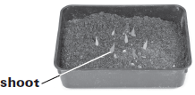
Explain why Sunita records when the shoot first appears and not when the root first appears.
.................................................................................................................
.................................................................................................................
1 mark
(d) Sunita planted five seeds of each type of seed in the trays.
Explain why it is a good idea to plant five seeds of each type rather than just one.
.................................................................................................................
.................................................................................................................
1 mark
(e) | This diagram shows the  life cycle of a plant. | 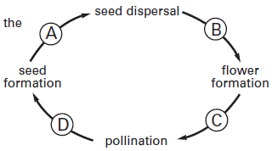
Tick ONE box to show where germination happens in the life cycle of a plant.
A B C D

