Monday 13th March 2023 – Raby Homework – LIVING THINGS
Q1.
Tree
(a) Ella is looking at some leaves.
The key below identifies which tree each leaf comes from. | 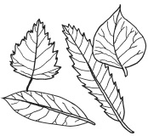
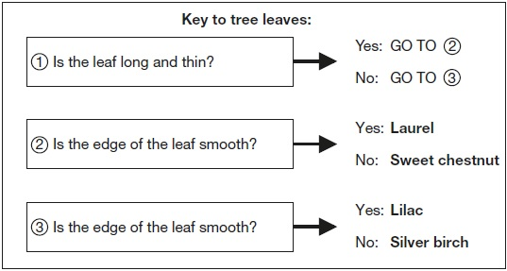

Look at this picture of a leaf from one of the trees. | 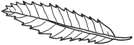
(i) Use the key above to identify the tree it comes from.
The leaf is from a ___________________________________________ tree.
1 mark
(ii) Tick ONE box to show why it is useful to identify plants and put them into groups.
 | so we know where to find a plant |  | because there is a large variety of plants
 | in case the plants become extinct |  | so we can observe the plants in their habitats
1 mark
(b) Complete the sentences below to show the function of the leaves and roots.
(i) The tree uses its leaves to ________________________________________.
1 mark
(ii) The tree has roots to ____________________________________________.
1 mark
(c) Ella finds a seed.
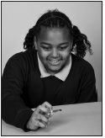
Why does the tree need to produce seeds?
___________________________________________________________________
1 mark
(d) Squirrels live in trees.
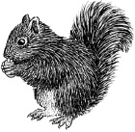
Give ONE feature of the squirrel from the picture.
Describe how this feature helps the squirrel to live in a tree.
Feature of the squirrel that helps it live in a tree: ____________________________
How the feature helps: ________________________________________________
___________________________________________________________________
1 mark

Q2.
Human life cycle and pulse rate
(a) Ella is learning about the human life cycle.
She collects pictures of people of different ages.
Label the photographs to name stages B and D in the human life cycle.
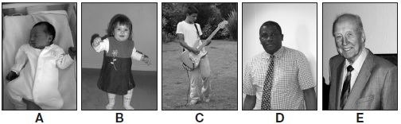
baby ____________ teenage ____________ old age
1 mark
(b) Ella wonders if pulse rate is affected by the different stages in the human life cycle.
Complete the sentence below about pulse rate.
Pulse rate measures how quickly the ____________ pumps blood around the body.
1 mark
(c) Ella measures the resting pulse rate of people from each of the life stages.
Ella’s test would not be fair if she measured some people’s pulse rates after they were exercising instead of after resting.
Explain why.
___________________________________________________________________
___________________________________________________________________
1 mark
(d) The table shows Ella’s results.

Stage of the human life cycle | Average resting pulse rate (beats per min)
A (baby) | 135
B | 97
C | 84
D | 72
E (old age) | 76
Ella concludes, ‘The older you are, the slower your resting pulse rate is.’
The evidence in Ella’s results does not support her conclusion.
Use Ella’s results to explain why they do not support her conclusion.
___________________________________________________________________
___________________________________________________________________
1 mark
(e) People who are fit have lower resting pulse rates than people who are unfit.
Write yes or no on each row of the table to show if the activities are likely to affect a person’s resting pulse rate.

 | Activity | Will the activity affect a person’s resting pulse rate? Yes or no?
 | swim every day
 | go for a walk every day
 | read every day
1 mark

