Raby Homework – Science – Living Things – 29.3.23
Q1.
Pond life
(a) Tom is finding out about pond life. He holds a glass bowl in the water and watches the pond life underneath.
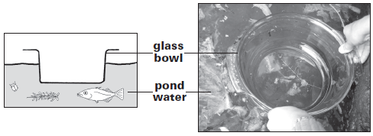
What property of the bowl allows Tom to see the pond life?
The glass bowl is ..................................................................................
1 mark
(b) The pictures below show some of the things Tom sees underneath the bowl.
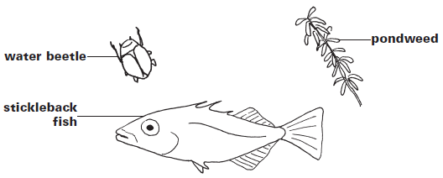
The stickleback fish is a predator.
Tick ONE box to show why the stickleback fish is a predator.
It eats plants. |  | It eats other  animals.
It hides near  pondweed. |  | It gets eaten by  other animals.
1 mark
(c) The pondweed is a producer.
Write true or false next to each of the following statements about producers.
 |  | True or false?
 | Producers are at the start of the food chain. | .............................
 | Producers catch their food from the water. | .............................
 | Producers use sunlight to make new  materials for growth. | .............................
1 mark
(d) | 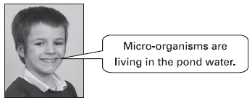
Tom
(i) Explain why Tom cannot see the micro-organisms in the water.
......................................................................................................
1 mark
(ii) Why does it help to have some micro-organisms living in the pond?
......................................................................................................
........................................................................................................

Q2.
Fish tank
(a) Philip’s class has some goldfish in a fish tank.
The picture below shows the fish tank.
Write solid, liquid or gas to complete each label on the diagram.
One has been done for you.
plastic lid inside the bubble
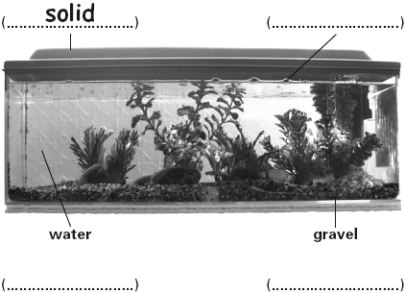
1 mark
(b) Philip needs to clean the fish tank.
He takes the fish and the plants out of the fish tank.

The teacher tips the dirty water and gravel from the fish tank into a sieve. | 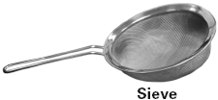
Complete the sentences below to show what happens to the gravel and the water when they are separated with the sieve.
The gravel ......................................................................................................
The water .......................................................................................................
1 mark
(c) There are micro-organisms in the gravel.
Write true or false next to each sentence about the micro-organisms living in the gravel.
True or false?
Micro-organisms...
are small enough to live in between the gravel. .......................
can break down leftover fish food. .......................
1 mark
(d) The micro-organisms living in the fish tank carry out life processes.
Tick TWO boxes to show which two statements about the life processes of the living micro-organisms are true.
In the fish tank...
the micro-organisms need nutrients.
the micro-organisms do not grow.
the micro-organisms do not reproduce.
the micro-organisms can move.
1 mark

