Headteacher : Mrs Donna Lee 12th May 2023

E-mail: d.lee103@nettlesworth.durham.sch.uk

Website: http// www.nettlesworth.durham.sch.uk
SummerTerm Newsletter

Year 6 and Year 2 SATs
Our Year 6 pupils and Year 2 completed their SATS assessments this week. They were more than ready for it and I am sure they will do themselves proud. They have worked hard all year and all week, this was an opportunity for them to show how much they have learned. We know they have all learned immense amounts during their time in school so there’s nothing to be worried about – just to do what they usually do, because they do it fantastically well! We are so proud of them.
Punctuality
It is great to see so many children arriving to school on time and being involved in their learning right from the beginning of the day. Class 1, 2 and Class 3 begin their phonics sessions at 8.45 am and Class 4 and Class 5 begin their challenge time activities at 8.45 am. We also have co-ordination programmes, reading/maths/speech and language interventions and lego therapy running at that time.
Being frequently late for school means lost learning:
- Arriving 5 minutes late every day adds up to over 3 days lost each year.
- Arriving 15 minutes late every day is the same as being absent for 2 weeks a year.
- Arriving 30 minutes late every day is the same as being absent for 19 days a year.

Lateness to School
School starts at 8:45 am. Your child will receive a late mark if they arrive after this time. If your child arrives after the register closes at 9.15 am they will be given an unauthorised late mark. Persistent Unauthorised late marks will result in a referral to the Local Authority School Improvement Officer for further intervention and enforcement action may be taken.
Please can you ensure children arrive at school for 8.45am. Thank you so much to parents/carers for your continued support.
Holidays in Term Time
We have seen a large increase in requests for holidays in term time. Due to this, our school attendance has fallen from 96.7% to 95.5%. Our school attendance target is 96%. This target is National Average. Ofsted evaluate school attendance and a low attendance can affect school’s Ofsted judgements. Just to remind parents and carers that as of 1st September 2013, Head Teachers may not grant any leave of absence during term time unless there are exceptional circumstances. Absence during term time should be avoided because children can fall behind with their work and may find it difficult to integrate. An application using the leave of absence form (available from the school office) for leave must be made in writing to the Head Teacher, detailing the exceptional circumstances. The Head Teacher must be satisfied the circumstances warrant the granting of leave. If you do not apply for leave in advance, the absence will be recorded as unauthorised. You can be fined for taking your child on holiday during term time without consent from the school.
Texts/Emails
We regularly send texts to parents with details of events happening in school or just reminders. We are now also sending emails. Thank you for your patience while we are updating this. Letters have been sent out explaining our new systems. Please notify school if you haven’t received any texts/emails in the last week. Your contact details may need updating.
School Website
Please continue to look at our school website on www.nettlesworth.durham.sch.uk for diary dates, latest news, celebrations, advice and information.

The Coronation of His Majesty King Charles 111

In school the children have been focusing on the Coronation of His Majesty King Charles III, throughout the curriculum in different subjects, assemblies and after-school clubs. It has been a fantastic build up to the King’s coronation ceremony which will take place on Saturday 6 May 2023, 11am at Westminster Abbey in London. On Friday 5th May 2023 the children and staff were invited to come into school wearing red, white and blue clothing to mark this amazing event that will be wrote in the History books for many years to come.
Each child will receive a commemorative coin for King Charles III

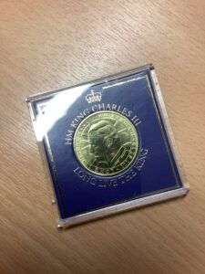

The coronation of the new Sovereign is an occasion for pageantry and celebration, but it is also a solemn religious ceremony that has remained essentially the same over a thousand years. For the last 900 years, the English coronation ceremony has usually taken place at Westminster Abbey in London. The service is conducted by the Archbishop of Canterbury, as it has almost always been since the Norman Conquest in 1066. For more details about the ceremony are available on the royal.uk website.
Part of the ceremony will focus on St Edward’s Crown, the crown historically used at the moment of coronation and last worn by Queen Elizabeth II at her Coronation in 1953. It was made for Charles II in 1661, as a replacement for the medieval crown which had been melted down in 1649.
Please see the PowerPoint for more information: Coronation-Ceremony-Assembly
Here are some of our highlights from this week in School:
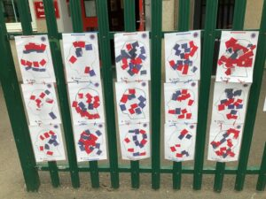

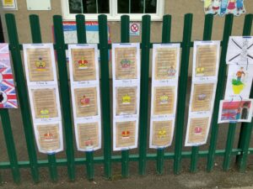

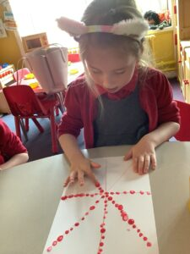

Diary Dates

WB Monday 15th May- Bikeability Y5/6 (Further details to follow)

Friday 26th May- End of Half Term

Monday 5th June- Children Return to School

Tuesday 6th June- Class Photographs

Thursday 8th June- New Reception Starters Parent/Carer Meeting

W/B Monday 12th June- Year 1 Phonics Screening Check and Year 4 Multiplication Times Tables Check

Monday 12th June- Y5/6 Robinwood Parents/Carers Meeting

Monday 12th June- Adam Bushnell (author) visits school

Wednesday 14th June- Eco Coffee Morning

Friday 16th June- Pyjama Day

Monday 19th June- New Reception Starters Visit 1

Tuesday 20th June- Sports Day

Wednesday 21st June- New Reception Starters Visit 2

Monday 26th June- New Reception Starters Visit 3

Tuesday 27th June- Year 5/6 Quidditch Festival

Wednesday 28th June- New Reception Starters Visit 4
- Class Swap Day
- Hermitage Secondary transition Day

Thursday 29th June- Hermitage Secondary Transition Day

Friday 30th June- Framwellgate Moor Transition Day

Saturday 1st July- School Summer Fayre

Wednesday 5th July- Year 5/6 Residential to Robinwood
- Class 1 Summer Showcase

Friday 7th July- End of Year School Reports to Parents/Carers

Monday 10th July- Parents Open Evening

Tuesday 11th July- Year 6 SATS Results

Wednesday 12th July- TT Rockstars Day

Thursday 13th July- Class 5 Summer Showcase

Friday 14th July- Arts/Culture Day

Tuesday 18th July- Year 6 Leavers Assembly
- Year 6 Prom

Friday 21st July- Picnic with Parents/Carers
- End of Term

Wednesday 6th September- Children return to school

Further letters/details will follow about each event

Absences
By law, all children of compulsory school age must get a suitable, full-time education. As a parent/carer, you are responsible for making sure this happens. Once your child is registered at Nettlesworth Primary School, you are responsible for making sure your child has regular and punctual attendance at school.
The Local Authority (LA) is responsible for making sure that parents/carers fulfil their responsibilities, and the school must tell the LA if your child is regularly absent from school. As a parent/carer, you are committing an offence if you fail to make sure that your child attends school regularly. You run the risk of being prosecuted by the LA if your child’s attendance is poor.
Reporting School Absence
We appreciate there may be times your child is unwell or unable to attend school. As a parent you have a responsibility to:-
- Contact school on the first morning of absence, providing a reason for their absence.
- Keep school informed on a regular basis if your child is absent for a long period.
- Provide medical evidence if this has been requested by the school
If school are not informed and unable to contact you via telephone regarding your child’s absence a letter will be sent requesting details of the absence or our Parent Support Advisor will come out and visit to see if you need any support. If this is not returned and still no reason for the absence is provided the absence will be marked as unauthorised.
Only head teachers can authorise absence and it is at their discretion as to whether the reason provided is acceptable or not.
If your child is unwell, please contact school office as soon as possible by 9am. It is important that children attend school as often as possible because if they are not in school they cannot learn.
The minimum acceptable level of school attendance is 96%. We believe as a school that identifying poor attendance and issues affecting attendance early as well as working in partnership with parents we can significantly improve attendance and prevent a child becoming a persistent absentee and involvement with the Local authority. Below outlines the procedure that we follow to support and improve attendance:
- Notice to Improve Letter – sent home to indicate to parents/cares that attendance is starting to decline. This will be sent to students below 96% attendance.
- Medical Evidence Request Letter – sent home to request medical evidence to be provided to support absence, without this future absence will be marked as unauthorised. This could be in the form of an appointment card or proof of medication given by the doctor
- Parents/carers to be invited to attend a school attendance meeting to discuss concerns and set targets to improve attendance.
- If your child’s attendance falls to 90% or below, this is considered, by the Government, to be persistent absence. Where attendance falls below 90% and there are unauthorised absences a referral will be made to the Local Authority School Improvement Officer for further intervention and enforcement action may be taken.

Inclusion Quality Mark Re-Assessment and Centre of Excellence Status 2023

Inclusion Quality Mark Re-Assessment 2023 and Centre of Excellence 2023
We are very proud to have been awarded this prestigious quality mark with Centre of Excellence Status which reinforces the work that we do to ensure that every child in our school is valued and has their education directly tailored to their learning needs. It represents the fact that we are a fully inclusive school who promote the social, emotional and academic well being of all of our pupils.
You can read the full report from the Quality Mark assessor by clicking on the link below.

Nettlesworth Primary School Report – April 2023

Wear a Hat Day 2023
Nettlesworth Primary school had lots of fun celebrating and raising awareness for Brain Tumours when taking part in Wear A Hat Day. We took part in a HATTASTIC quiz and crowned the winning team with a super-amazing hat trophy. It was great to see so many hats of all different shapes and sizes – Well done everyone
We would like to say a huge thank you to all of our parents and carers for helping to raise £75.00
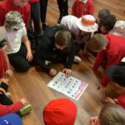

Health and Well Being Day with Marie Claire
Today we have had lots of fun with Marie-Claire learning about the different ways that we can complete our daily Active 60.
We began the day with an assembly, learning about the importance movement has on our mental health and well being

Class 1
UNCRC Article 31 – Right to take part in a wide range of activities.
Class 1 had lots of fun doing some active yoga. We learnt lots of yoga positions and could do these whilst moving around the hall. We explored different yoga poses on our spots and added animal actions to remember them. Marie-Claire was amazed at our balance and control

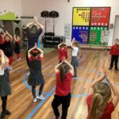
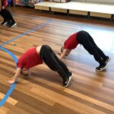

Class 2
We worked on our active yoga. We demonstrated our fundamental movement skills as well as our flexible moves.

Class 3
UNCRC Article 31 – Right to take part in a wide range of activities.
Class 3 had lots of fun doing some active yoga. We learnt lots of yoga positions and could do these whilst moving around the hall. We learnt how to do yoga poses both on our own and with a partner. Marie-Claire was so impressed with our flexibility and balance.

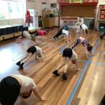

Class 4
This afternoon, Class 4 had the chance to take part in a Step Fit aerobics class as part our own Health & Wellbeing Day with Marie-Claire. We loved coming up with our own routines after learning the moves from Marie-Claire and are aiming to continue to do at least 60 minutes of being active every day – even when not in school! Well done everyone.
UNCRC Article 31 – every child has the right to take part in a wide range of activities.
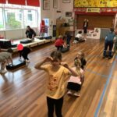
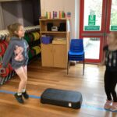

Class 5

UNCRC Article 31 – leisure, play and artistic culture
A fabulous session with Marie Claire saw Class 5 participating in Step Fit for an hour. The whole class demonstrated Rights Respecting Gold throughout with their determination and willingness to complete each exercise.

Litter Picking
Class 2 worked with John, a neighbourhood warden, to learn bout the importance of looking after our local area as well as our environment. We discussed how litter picking can be really helpful way of looking after our world around us. Look at us go …. making sure our school grounds are spotless!

