Science Homework – Class 5 Bamburgh & Alnwick – 2.5.23 Name:_______________
Q1.
Forces
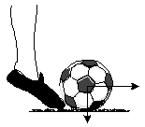
The girl is kicking the football.
The arrows show the direction of two forces on the ball.
Draw TWO arrows on each of these pictures to show two forces on each football.
(a) Moving to the right through the air.
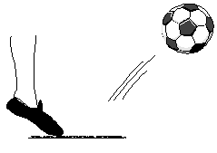
2 marks
(b) Not moving, on the ground.
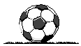
2 marks

Q2.
Forces
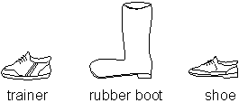
Some children did an experiment to find out which footwear had the best grip.
They tied a string to a shoe.
They put weights (masses) in the pan until the shoe just started to move.
(a) Draw an arrow on the diagram to show the direction in which the shoe will move.
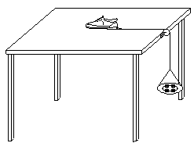
1 mark
(b) Name the force which is pulling downwards on the pan and weights.
......................................................................................................................
1 mark
(c) Name the force resisting the shoe sliding across the table.
......................................................................................................................
1 mark
(d) The children recorded their results.
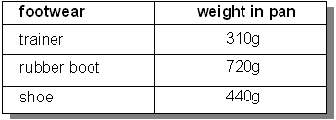
How will the children use their results to decide which footwear has the best grip?
Q3.
Weighing Bricks
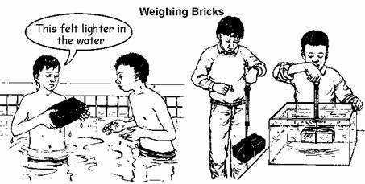
(a) The children weigh bricks using a forcemeter.
In air the forcemeter reads 35N with the rubber brick and 30N with the house brick.
In water the forcemeter reads 10N with the rubber brick and 12N with the house brick.
Complete the table to show the readings on the forcemeter.
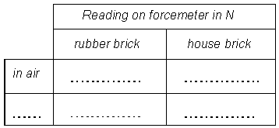
2 marks
(b) The forcemeter spring is stretched when a brick is hung on it.
Name the force which pulls down on the brick.
......................................................................................................................
1 mark
(c) Why is the pull on the forcemeter different for the rubber brick and the house brick?
......................................................................................................................
......................................................................................................................
1 mark
(d) The forcemeter readings are greater in air than in water.
Why is this?
Q4.
Sinking and Floating
(a) The children made shapes with modelling clay.
The solid ball sank.
The boat floated.
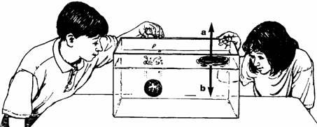
Look at the picture.
Write the names of the TWO forces a and b acting on the boat.
Force a ........................................
1 mark
Force b ........................................
1 mark
(b) The ball and the boat each have a mass of 200 g.
Explain how the forces a and b make the boat float.
......................................................................................................................
......................................................................................................................
1 mark
(c) Stacey made four hollow balls of modelling clay, each of 200 g.
She hung the balls from a forcemeter, first in the air, then in water.
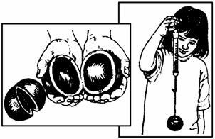
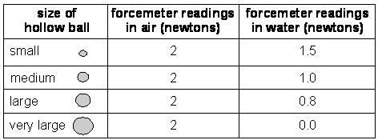
What pattern do you notice between the size of the hollow balls and the forcemeter readings in water?
......................................................................................................................
......................................................................................................................
1 mark
(d) Explain why the forcemeter readings are lower in water than in air.
......................................................................................................................
......................................................................................................................
1 mark
1 mark
(b) Hilary puts twelve paperclips on the string of her balloon.
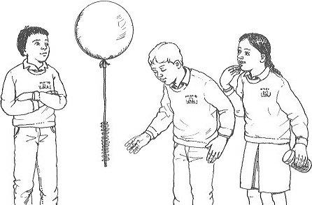
The balloon stays at the same height above the floor of the classroom when she lets go.
Explain why the forces acting on Hilary’s balloon, with twelve paper clips on the string, make it stay at the same height.
......................................................................................................................
......................................................................................................................
1 mark

