Science Homework – Class 5 Lindisfarne & Lumley – 2.5.23 Name:_______________
Q1.
Dropping modelling clay
(a) Sarah makes five different shapes using modelling clay.
She uses the same amount of clay for each shape.
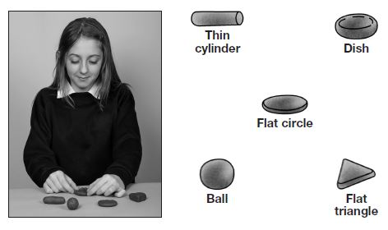

Sarah fills a container with syrup.
She drops each shape into the syrup.
She times how long it takes each shape to reach the bottom of the container.
Tick ONE box to show why clay is a good material to use to make different shapes.
Clay can float. |  | Clay is soft and flexible.
Clay dissolves in water. |  | Clay is a heat insulator.
1 mark
(b) Here are Sarah’s results:  Which shape fell the fastest? | Shape | Time to reach the bottom of the container (seconds)
 | thin cylinder | 1.0
.................................................. | dish | 8.0
 | flat circle | 4.0
 | ball | 0.5
 | flat triangle | 4.0
1 mark
(c) Sarah found it difficult to time some of the shapes accurately.
Tick ONE box to show why Sarah found it difficult to time some of the falling shapes.
They are made out of the same amount of clay. |  | They fell at different speeds.
They fell quickly through the syrup. |  | They are different shapes.
1 mark
(d) There is a force from the syrup acting on the shapes as they fall.

Draw ONE arrow on the diagram  to show the direction of the  force from the syrup on the ball. | 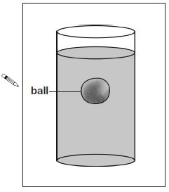
1 mark

Q2.
Friction
(a) Friction is the force which causes moving objects to slow down and stop.
Tick THREE boxes to show which activities are only possible because there is a small amount of friction.
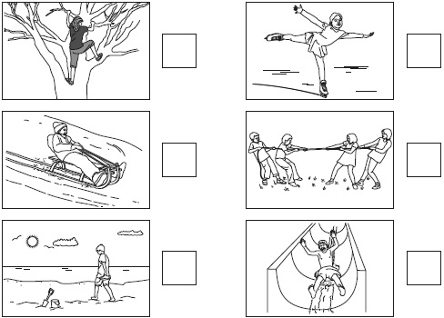
2 marks
(b) Sue rolls a car down a ramp. She investigates how far the car travels along different surfaces before friction causes the car to stop.
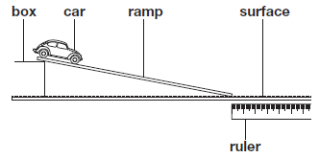
Name ONE variable Sue must keep the same to make her test fair.
........................................................................................................................
1 mark
(c) Sue draws a table of the results.

 | Surface | Distance travelled by car (cm)
 |  | first try | second try | third try
 | tiles | 105 | 72 | 107
 | carpet | 50 | 46 | 45
 | paving stones | 68 | 66 | 67
 | wooden floor | 124 | 129 | 131
Sue looks at the table.
She thinks she should test one of the surfaces again.
(i) Which of these surfaces should Sue test again?
................................................
1 mark
(ii) Describe how the evidence in the table shows that Sue should test this surface again.
................................................................................................................
................................................................................................................
1 mark
(d) Look at the table of results.
Tick ONE box to show which surface caused the most friction.
tiles |  | carpet
paving stones |  | wooden floor
1 mark

Q3.
Parachutes
(a) Jamie has a parachute. The two arrows on the diagram below show two forces (A and B) acting on the falling parachute.

Label forces A and B on the diagram below.  (i) Force A is ..................................................  (ii) Force B is .................................................. | 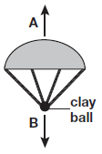
2 marks
(b) Tick ONE box to show the effect force A has on the parachute.
It makes the parachute fall faster. |  | It makes the parachute heavier.
It makes the parachute fall slower. |  | It makes the parachute lighter.
1 mark
(c) Jamie wants to find out if changing the material of the parachute affects the time it takes to fall to the ground.
The table shows some of the variables in Jamie’s investigation.
Complete the table to show how Jamie should do his investigation. Tick ONE box in each row.
Variable | Variable to be changed | Variable to be measured | Variable to be kept the same
height of drop
mass of modelling clay
size of parachute
material of parachute
time taken to fall to the ground
2 marks
(d) Jamie decides to test each of his parachutes three times.
He records his results in the table below.
One of the times in his results table looks wrong.
Circle ONE time in the results table that Jamie should check.
 | Parachute material | Time taken to reach the ground (seconds)
 |  | test 1 | test 2 | test 3
 | plastic | 2.4 | 2.4 | 2.5
 | bubble wrap | 2.1 | 2.0 | 2.0
 | netting | 2.9 | 1.0 | 1.0
1 mark
(e) Jamie makes a smaller parachute made of plastic.
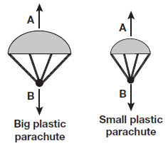
Predict the time it will take the smaller plastic parachute to fall to the ground.
................................................... seconds
1 mark

