Science Homework – Class 5 Raby – 2.5.23 Name:_______________
Q1.
Magnetic forces
(a) Ali has four different magnets and some paperclips.
The paperclips are attracted to the magnets.
Draw ONE arrow on the photograph to show the direction of the magnet’s force on the paperclip.
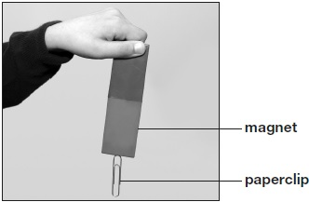
1 mark
(b) Name the force on the paperclip that pulls in the opposite direction to the magnet.
___________________________
1 mark
(c)
Ali wants to find the strongest magnet. He adds paperclips to a magnet one at a time so they make a chain. He stops when no more paperclips stick.  He repeats this with the other three magnets. | 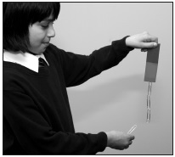
How will Ali know which magnet is the strongest?

(d) The graph below shows Ali’s results.
One axis on the graph has been labelled.
 | Write the label for the other axis.  ________________________  ________________________ | 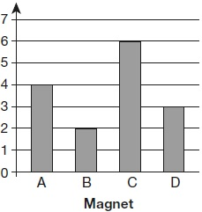
1 mark
(e) Ali moves magnet A towards magnet B.
Magnet B moves away from magnet A even though Ali does not touch magnet B.
Why did magnet B move away from magnet A?
___________________________________________________________________
1 mark
(f) Ali tries different ways of putting the magnets together.
Tick ONE box on each row of the table to show if the magnets move together, move apart or do not move.
The first one has been done for you.
Magnets | Move together | Move apart | Do not move
 | ✔
1 mark

Q2.
Investigating grip
(a) Andy and Jun have different ways of testing how well different shoes grip.
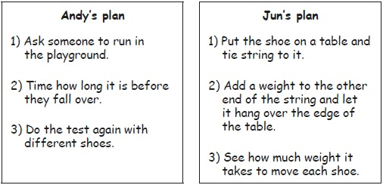
Complete the table below to show the units that Andy and Jun could use to measure their results.

What will be measured? | What is the unit of measurement?
how much time it takes to fall over | _____________
how much weight it takes to move the shoe | _____________
2 marks
(b) Andy and Jun both plan to make their tests fair.
Suggest ONE reason why Jun’s plan is better than Andy’s plan.
Jun’s plan is better because ____________________________________________
___________________________________________________________________
1 mark
(c) They decide to use Jun’s plan to test some shoes.
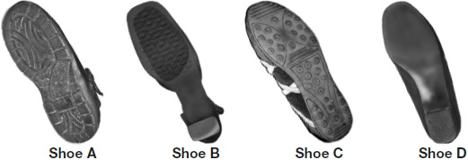
Jun predicts that shoe D will have the least grip. Look at the shoes.
Explain why shoe D is likely to have the least grip.
___________________________________________________________________
1 mark
(d) Look at the table of results.

Shoe | A | B | C | D
Weight needed to move the shoe (units) | 250 | 100 | 125 | 25
Do the results support Jun’s prediction that shoe D will have the least grip? Tick ONE box.
 | yes |  |  | no
Explain how the results support or do not support Jun’s prediction.
___________________________________________________________________
___________________________________________________________________
1 mark

