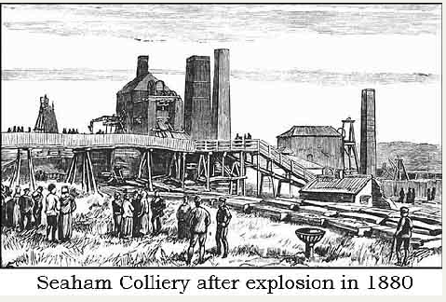
For this week’s homework, your task is to describe a story setting based around our Cornerstones Curriculum Firedamp & Davy Lamps; coal-mining. Try to use an old colliery that you have been working on in class.
What can you see?
What can you hear?
What can you smell…?
Try to include as much figurative language as possible to produce an atmosphere in your writing.
Your goal is to use: appropriate vocabulary (adjectives, adverbs, adverbials…), wide range of accurate punctuation, variety of extended sentence structure (simple, compound and complex sentences)…
Now for the good (challenging) part…
You are only allowed to use 100 words in total!
Can you complete the 100 word story setting challenge?
You could start with - Looking around I saw…
