Name:_______________________ Monday 5th June 2023
L.O. – I can recognise the basic style indicators of Wartime Music – Listen and Appraise
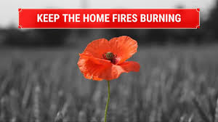
Wartime Music
Keep the Home Fires Burning
– Ivor Novello

"Keep the Home-Fires Burning (Till the Boys Come Home)" is a British patriotic First World War song composed in 1914 by Ivor Novello with words by Lena Guilbert Ford (whose middle name was sometimes printed as "Gilbert"). A new edition was printed in 1915 with the name "Keep the Home-Fires Burning".

Do you like the song?

What can you hear?

What is the style of this music?

How is the song put together (How does it start; what’s the middle / ending like…?

Can you practise singing this song?

