Polar Bears Threatened
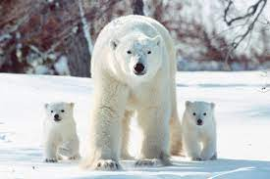
Read the report about Polar Bears being Threatened.

- Can you make brief notes about the main points from the report?

- What is the conclusion of the report?

- What main points does it make to support this conclusion?

- Do you agree or disagree with this report

- Can you think of 3 question you would like to ask how YOU could help endangered Polar Bears?

